S.NO | NAME OF EXPERIMENTS
1. | Lab on web services
2. | Lab on IPC, messagaging, publish/subscribe
3 | Install Virtual box/VMware Workstation with different flavours of linux or windows  OS on top of windows7 or8.
4. | Install a C compiler in the virtual machine created using virtual box and execute Simple Programs
5. | Create an Amazon EC2 instance and set up a web-server on the instance and associate an IP address with the instance. In the process, create a security group allowing access to port 80 on the instance.  OR  Do the same with OpenStack
6.
7 | Install Google App Engine. Create hello world app and other simple web applications using python/java
8 | Start a Docker container and set up a web-server (e.g. apache2 or Python based Flask microweb framework) on the instance. Map the host directory as a data volume for the container
9 | Find a procedure to tansfer the files from one virtual machine to another virtualmachine. Similarly, from one container to another container
10 | Find a procedure to launch virtual machine using trystack (Online Openstack  DemoVersion)
11 | Install Hadoop single node cluster and run simple applications likewordcount.
12 | Utilize OpenFaaS – Serverless computing framework and demonstrate basic event driven function invocation.
13 | Simulate a cloud scenario using CloudSim and run a scheduling algorithm that is not  presentin CloudSim

EXP NO -1
Aim:
To understand the basic concepts, architecture, and functioning of Web Services including SOAP, REST, WSDL, and UDDI.

What are Web Services?
Web services are standardized ways to allow different applications to communicate over the internet using XML or JSON. They are platform-independent, language-independent, and based on open standards.

🔹 Key Components:
1. SOAP (Simple Object Access Protocol):
- Protocol based on XML.
- Defines how messages should be formatted and transmitted.
- Used for tightly-coupled, enterprise-level services.
- Typically uses HTTP, SMTP as transport protocols.
Example SOAP message:
xml
CopyEdit
<soap:Envelope>
<soap:Body>
<getWeather>
<city>Hyderabad</city>
</getWeather>
</soap:Body>
</soap:Envelope>

2. REST (Representational State Transfer):
- Architecture style, not a protocol.
- Uses HTTP methods (GET, POST, PUT, DELETE).
- Based on resources identified by URLs.
- Uses JSON or XML for data exchange.
- Lightweight and widely used in mobile/web apps.
Example REST API call:
nginx
CopyEdit
GET https://api.example.com/users/101

3. WSDL (Web Services Description Language):
- XML-based language to describe the functionality of a SOAP web service.
- Contains:
  - <types>: data types
  - <message>: input/output messages
  - <portType>: operations
  - <binding>: communication protocols
Use: Allows clients to understand how to interact with the web service.

4. UDDI (Universal Description, Discovery, and Integration):
- A directory service where businesses can register and discover web services.
- Think of it as a "Yellow Pages" for web services.
- Helps in service discovery and service lookup.

🔹 Comparison Table: SOAP vs REST
Feature | SOAP | REST
Type | Protocol | Architectural style
Data Format | XML only | XML, JSON, HTML, plain text
Speed | Slower | Faster
Complexity | High | Low
Caching | No | Yes
Standards | WSDL | HTTP

🔹 Result:
The concepts and architecture of SOAP, REST, WSDL, and UDDI were successfully understood and documented.

🔹 Viva Questions:
- What is the difference between SOAP and REST?
- What is WSDL and what does it contain?
- What is the role of UDDI in web services?
- Which is better for mobile app APIs—SOAP or REST? Why?
- Can REST use protocols other than HTTP?

EX NO 2: Inter-Process Communication (IPC), Messaging, and Publish/Subscribe Models
AIM: To implement and understand various communication mechanisms like:
Lab Objectives:
- Understand various IPC mechanisms.
- Implement process communication using Pipes, Shared Memory, and Message Queues.
- Demonstrate Messaging using Sockets.
- Implement a basic Publish/Subscribe model using Python.

📘 Theory Overview:
🔹 Inter-Process Communication (IPC):
IPC is a mechanism that allows processes to communicate with each other and synchronize their actions.
Types of IPC:
- Pipes: Unidirectional communication.
- Message Queues: Send/receive structured messages.
- Shared Memory: Memory segment shared between processes.
- Sockets: Communication over a network or localhost.

🔹 Messaging:
Messaging is a form of communication between software components. IPC mechanisms can be used to pass messages between processes.

🔹 Publish/Subscribe Model:
A messaging pattern where:
- Publisher: Sends messages.
- Subscriber: Receives messages of interest.
- A Broker handles distribution.

🔹 1. IPC Using Pipes in C (Parent to Child)
c
// pipe_example.c
#include <stdio.h>
#include <unistd.h>

int main() {
int pipefd[2];
char buffer[20];

pipe(pipefd);
if (fork() == 0) {
// Child
read(pipefd[0], buffer, sizeof(buffer));
printf("Child received: %s\n", buffer);
} else {
// Parent
write(pipefd[1], "Hello Child", 12);
}
return 0;
}

🔹 2. IPC Using Shared Memory in C
c
CopyEdit
// shared_memory.c
#include <stdio.h>
#include <sys/ipc.h>
#include <sys/shm.h>
#include <string.h>

int main() {
key_t key = ftok("shmfile", 65);
int shmid = shmget(key, 1024, 0666 | IPC_CREAT);
char *str = (char *) shmat(shmid, NULL, 0);

strcpy(str, "Shared memory communication");
printf("Data written in memory: %s\n", str);

shmdt(str);
return 0;
}
🔹 3. Socket Messaging in Python
Server:
python
CopyEdit
# socket_server.py
import socket
s = socket.socket()
s.bind(('localhost', 12345))
s.listen(1)
conn, addr = s.accept()
data = conn.recv(1024)
print("Received from client:", data.decode())
conn.close()
Client:
python
CopyEdit
# socket_client.py
import socket
s = socket.socket()
s.connect(('localhost', 12345))
s.send(b"Hello from client")
s.close()
🔹 4. Publish/Subscribe Using Python and paho-mqtt
Install MQTT broker and client:
bash
CopyEdit
pip install paho-mqtt
Publisher:
python
CopyEdit
# pub.py
import paho.mqtt.publish as publish
publish.single("topic/test", "Hello Subscribers", hostname="test.mosquitto.org")
Subscriber:
python
CopyEdit
# sub.py
import paho.mqtt.client as mqtt

def on_message(client, userdata, message):
print("Received:", message.payload.decode())

client = mqtt.Client()
client.connect("test.mosquitto.org")
client.subscribe("topic/test")
client.on_message = on_message
client.loop_forever()
result:

🎓 Viva Questions
- What is Inter-Process Communication (IPC)?
- What are the differences between Pipes and Shared Memory?
- How does message queue differ from shared memory?
- What are named and unnamed pipes?
- What is socket programming?

EX.No:3 Install Virtualbox/VMwareWorkstation

Aim:

PROCEDURE TO INSTALL
Step 1- Download Link
Link for downloading the software is https://www.vmware.com/products/workstation-pro/workstation- pro-evaluation.html. Download the software for windows. Good thing is that there is no signupprocess. Click and download begins. Software is around 541MB.

Step 2- Download the installer file
It should probably be in the download folder by default, if you have not changed the settings in your browser. File name should be something like VMware-workstation-full-15.5.1-15018445.exe. This file name can change depending on the version of

the software currently available for download. But for now, till the next version is available, they will all be VMware Workstation 15 Pro.

Step 3- Locate the downloaded installer file
For demonstration purpose, I have placed the downloaded installer on my desktop. Find the installer on your system and double click to launch the application.

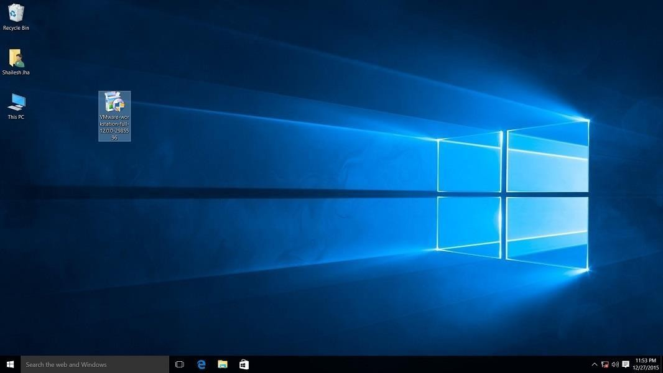

VMware workstation 15 pro for windows 10 installer file screenshot.

Step 4- User Access Control (UAC) Warning
Now you should see User Access Control (UAC) dialog box. Click yes to continue.

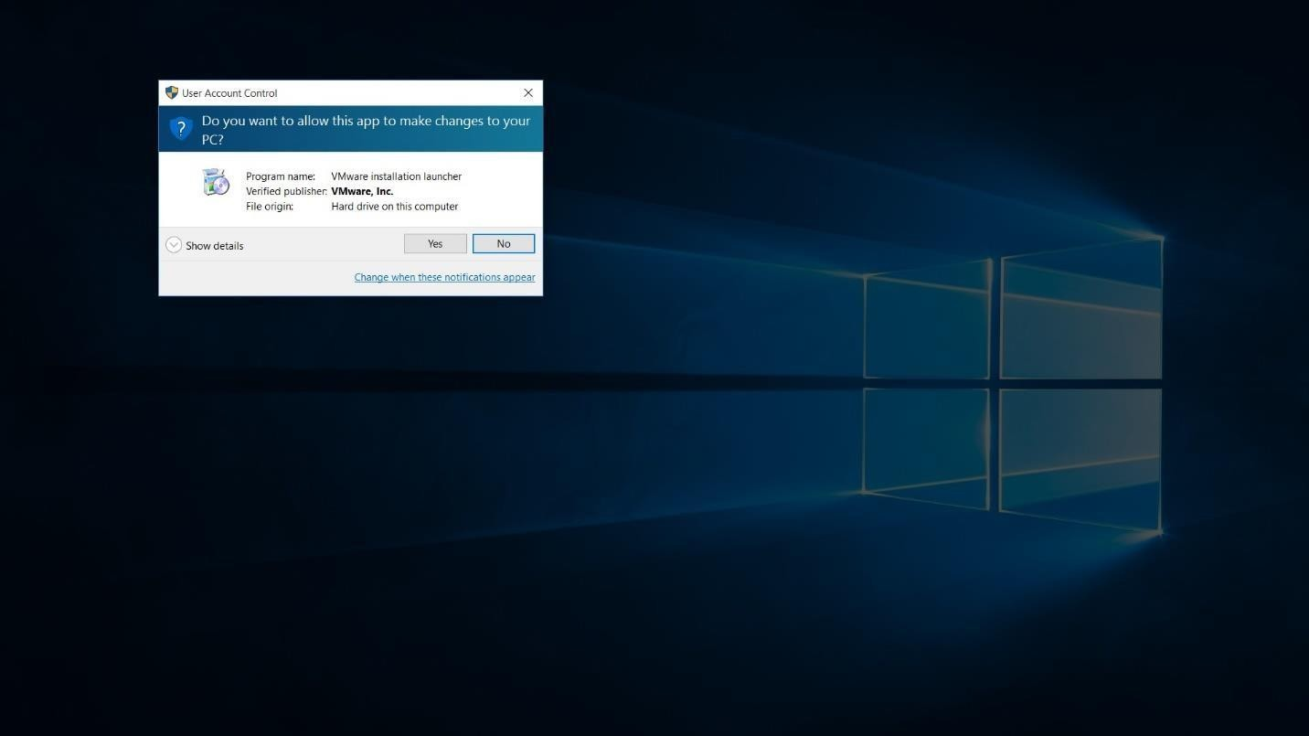
Initial Splash screen will appear. Wait for the process to complete.

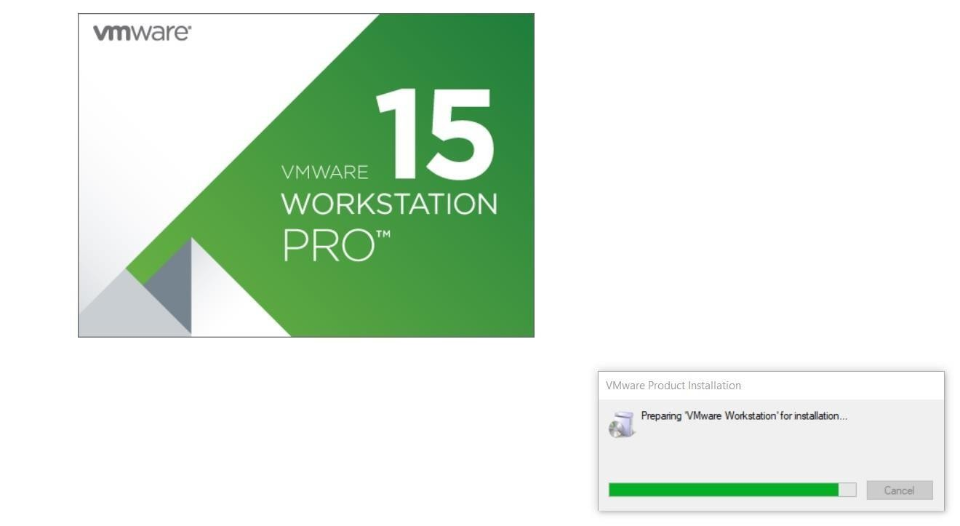

Step 5- VMware Workstation Setup wizard
Now you will see VMware Work station setup wizard dialog box. Click next to continue.

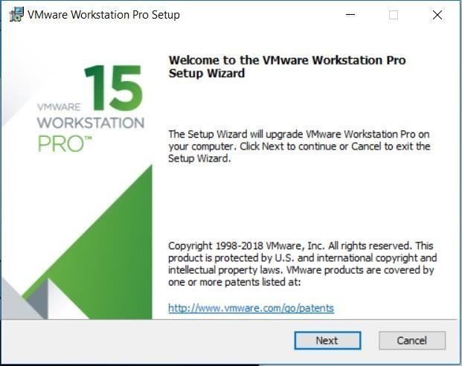

Step 6- End User Licence Agreement
This time you should see End User Licence Agreement dialog box. Check “I accept the terms in the Licence Agreement” box and press next to continue.
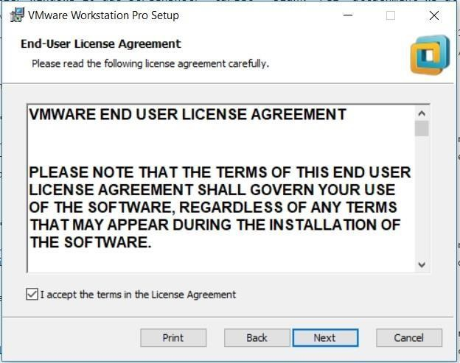

Step 7- Custom Setup options
Select the folder in which you would like to install the application. There is no harm in leaving the defaults as it is. Also select Enhanced Keyboard Driver check box.
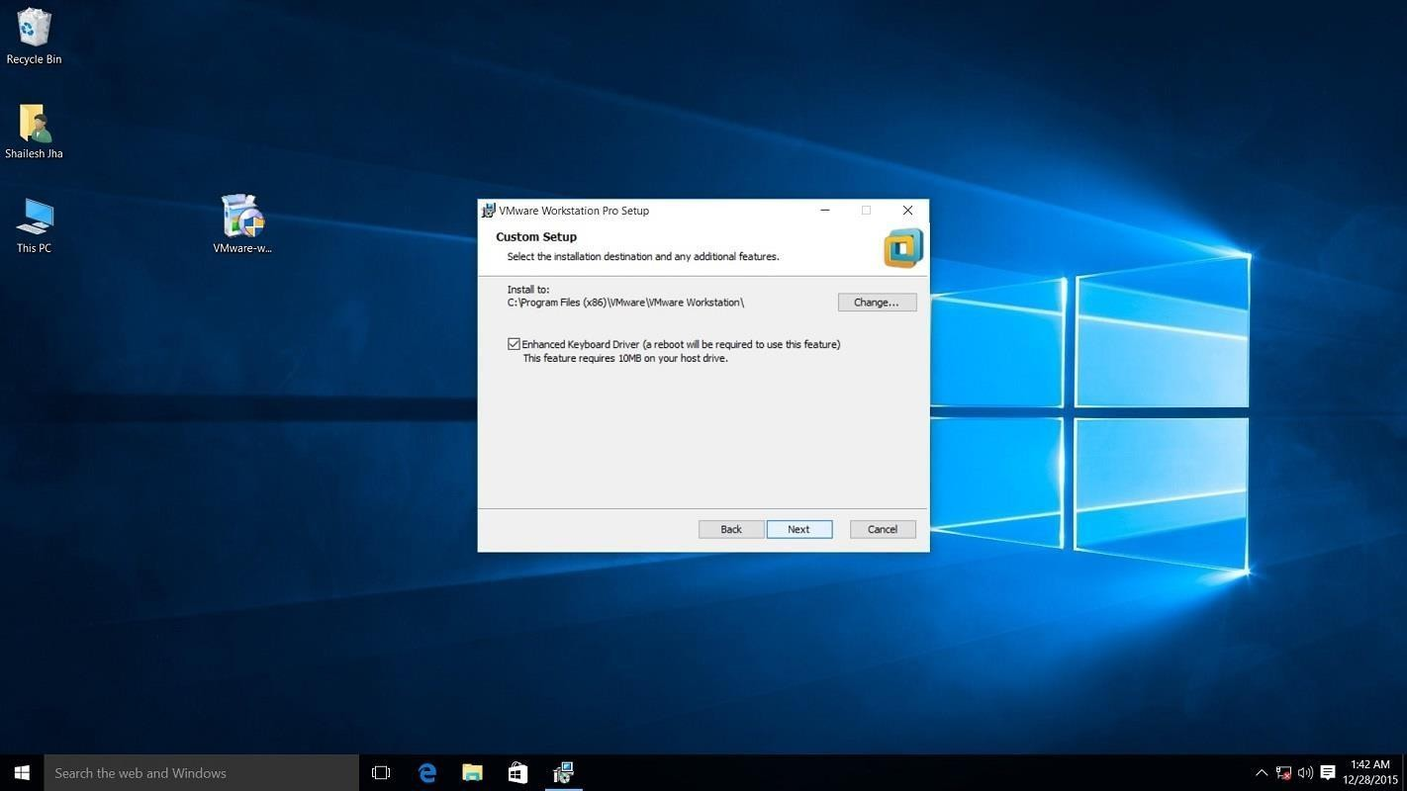

VMware Workstation 15 Pro installation – select installation folder

Step 8- User Experience Settings
Next you are asked to select “Check for Updates” and “Help improve VMware Workstation Pro”. Do as you wish. I normally leave it to defaults that is unchecked.
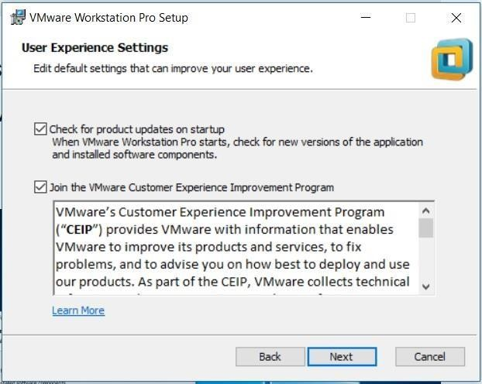

VMware Workstation 15 Installation – User Experience Settings
Step 9- Application Shortcuts preference
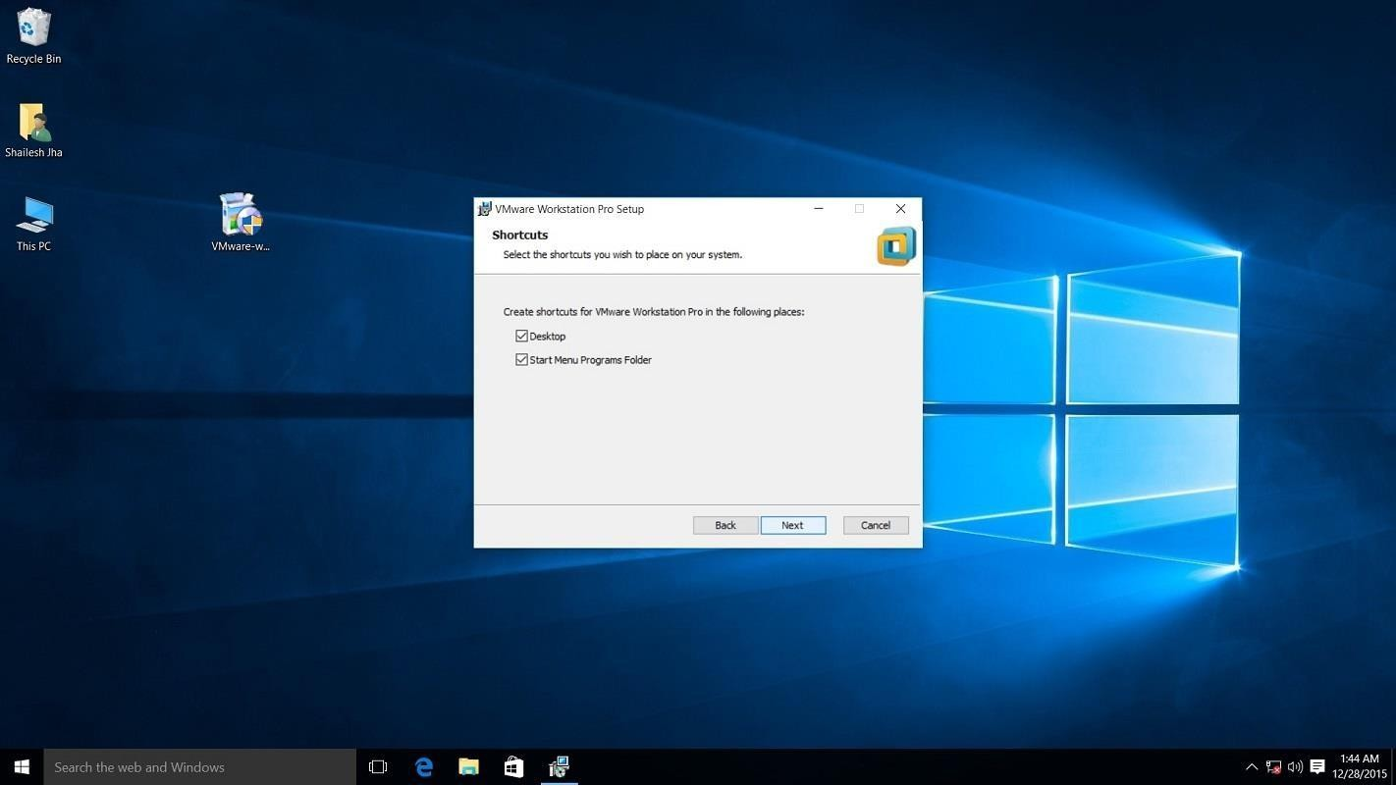
Next step is to select the place you want the shortcut icons to be placed on your system to launch the application. Please select both the options, desktop and start menu and click next.

Step 10- Installation begins
Now you see the begin installation dialog box. Click install to start the installation process.
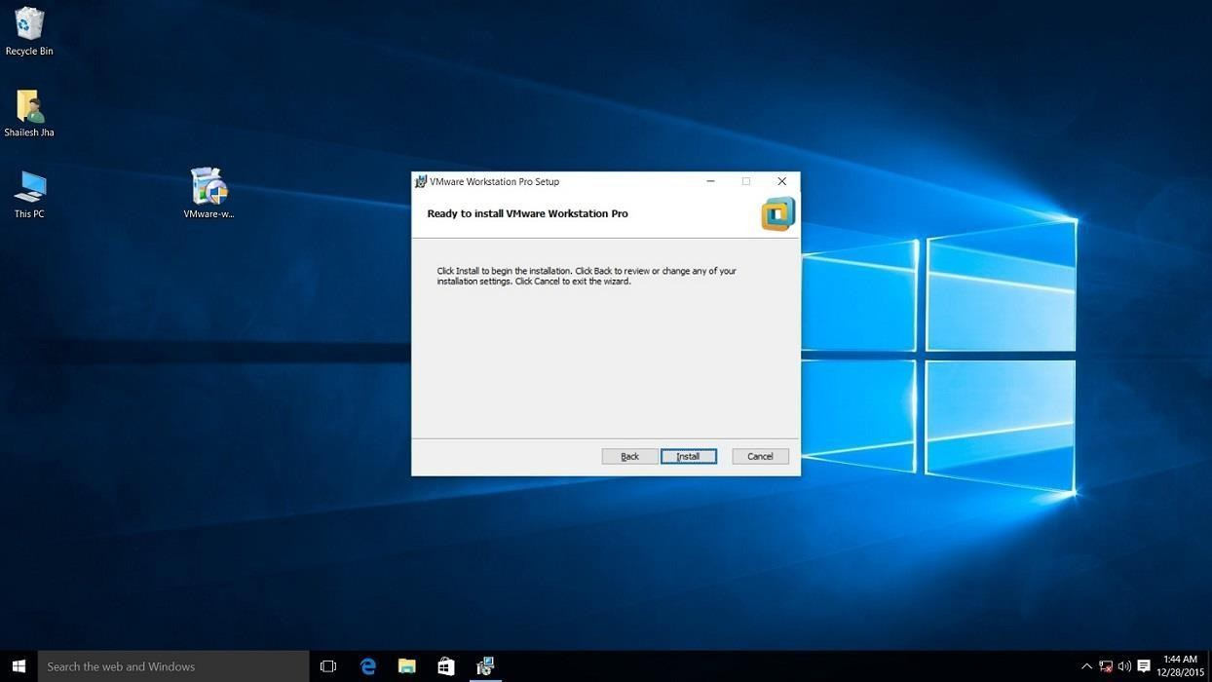

Screenshot for VMware Workstation 15 pro installation begin confirmation dialog box on windows 10.

Below screenshot shows Installation in progress. Wait for this to complete
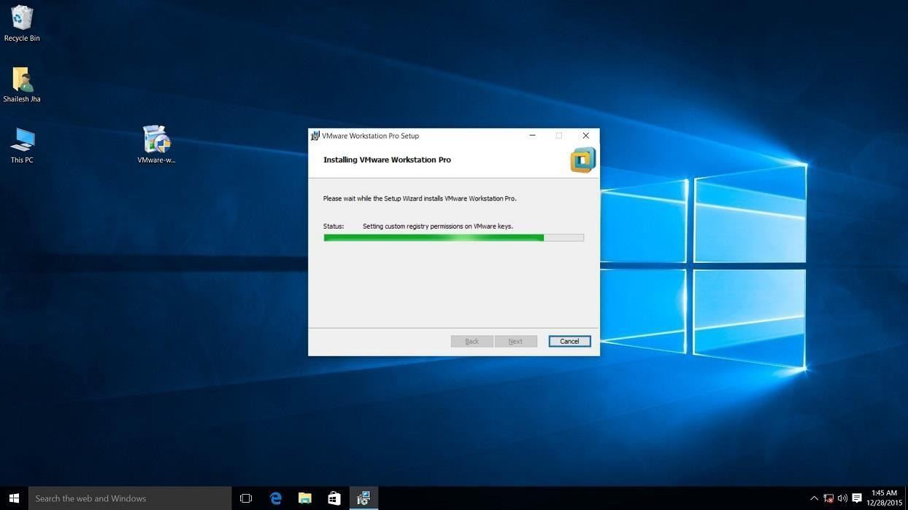

At the end you will see installation complete dialog box. Click finish and you are done with the installation process. You may be asked to restart your computer. Click on Yes to restart.
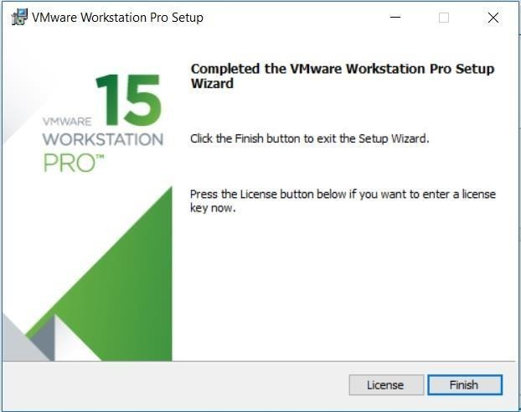

Step 11- Launch VMware Workstation
After the installation completes, you should see VMware Workstation icon on the desktop. Double click on it to launch the application.
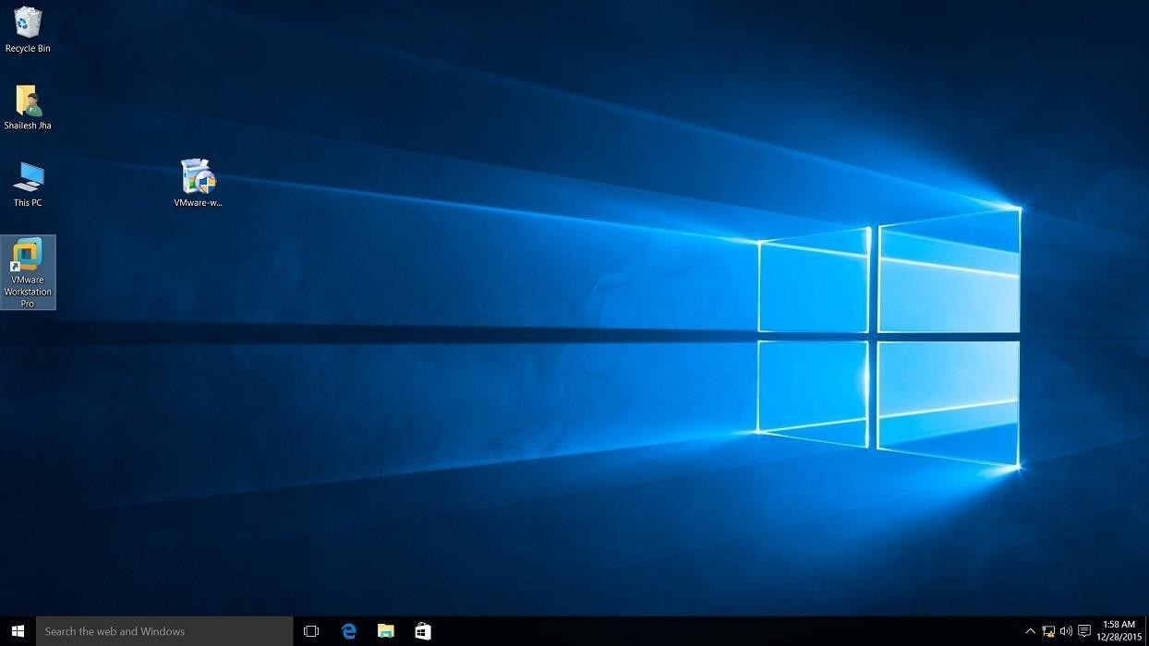

Screenshot for VMware Workstation 15 Pro icon on windows 10 desktop.
Step 12- Licence Key
If you see the dialog box asking for licence key, click on trial or enter the licence key. Then what you have is the VMware Workstation 15 Pro running on your windows 10 desktop. If don’t have thelicence key, you will have 30 daystrial.

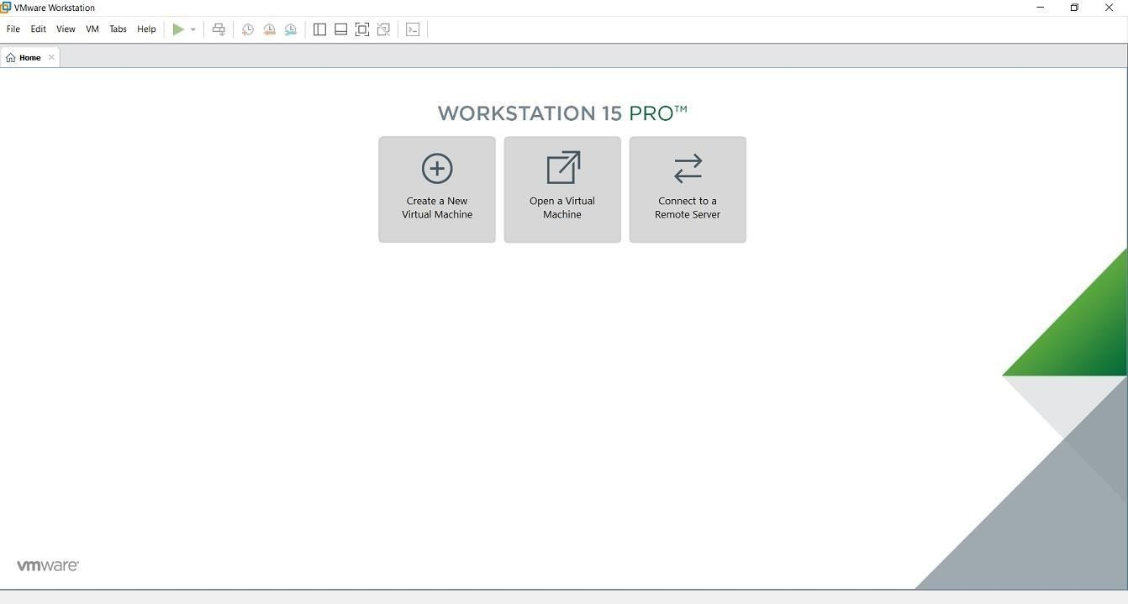

VMware Workstation 15 Pro home screen
Step 13- At some point if you decide to buy
At some point of time if you decide to buy the Licence key, you can enter the Licence key by going toHelp->EnteraLicenceKey You can enter the 25 character licence key in the dialog box shown below and click OK. Now you have the licence version of thesoftware.

Result:
Thus the VMware workstation is created on windows7.

VIVA QUESTIONS

- What is virtualization?
- Name any two virtualization tools.
- What is the purpose of a virtual machine?
- What is the difference between VirtualBox and VMware?
- Define Host OS and Guest OS.

Exno 4.a: Setting up C Programming Environment

Aim:
To Setup the virtual machine and install the c compilerin virtual machine.

A.Install VirtualBox

I.Visithttp://www.virtualbox.org/wiki/downloads

- Download VirtualBox platform packages for yourOS

- Open the Installation Package by double clicking

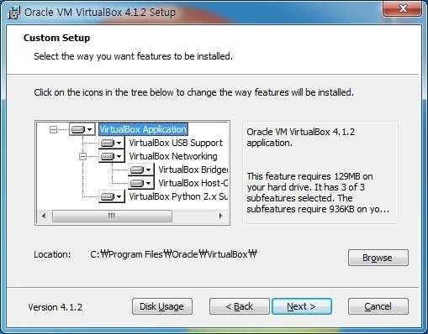

- Click continue and finish installingVirtualBox
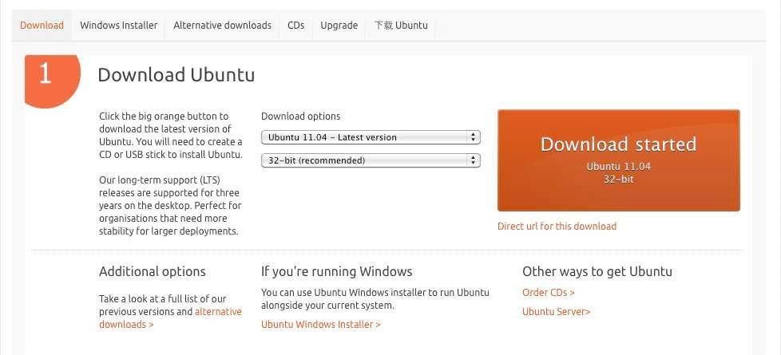
CLI
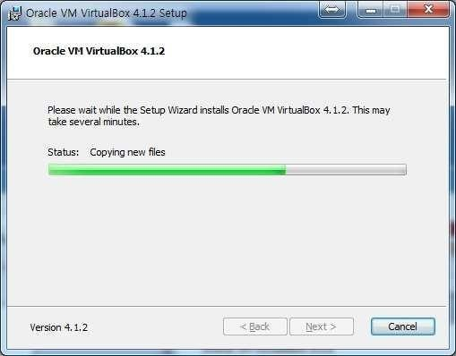
PC

- When finished installation, close thewindow.

Download Linux
  - Visit the pagehttp://www.ubuntu.com/download/ubuntu/download
  - Choose the Latest version of Ubuntu and32-bit and click “StartDownload”

- Run VirtualBox by double-clicking theicon

- Click “New” button on the top leftcorner
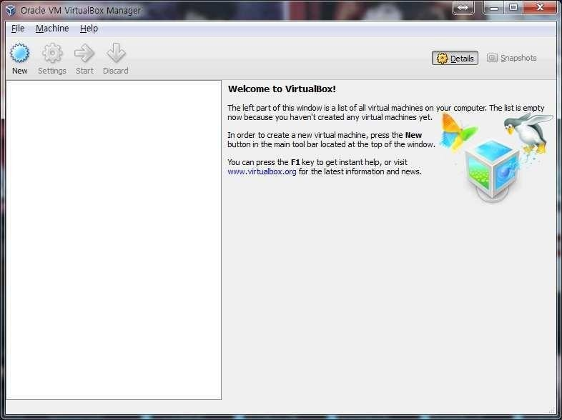

PC

- Click “Continue” on the pop-upwindow

- TypeVMname,select“Linux”fortheOSandchoose “Ubuntu” for theversion.

- Choose the amount of memory to allocate (I suggest choosing between 5I2 MB to I024MB)

- Click Continue orNext

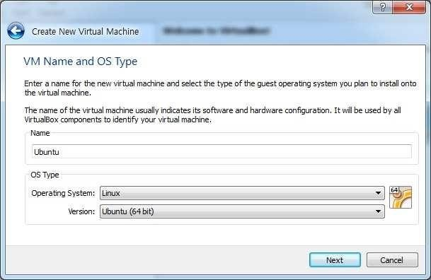
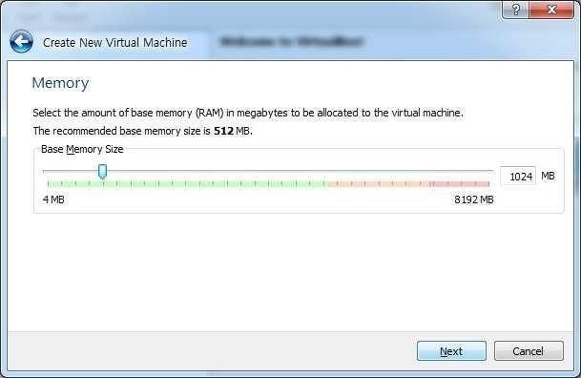
PC

- Choose create a new virtual harddisk

- Click Continue orNext

PC
- Choose VDI (VirtualBox DiskImage) I0. Click Continue orNext

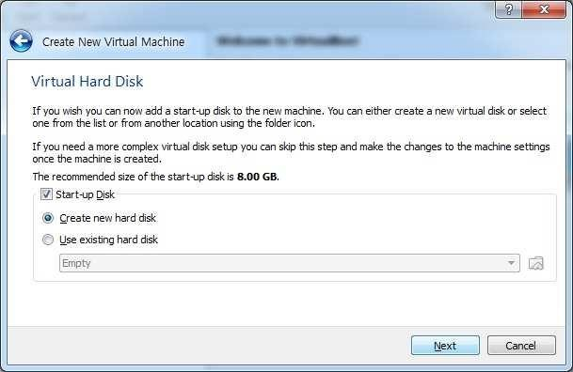
PC

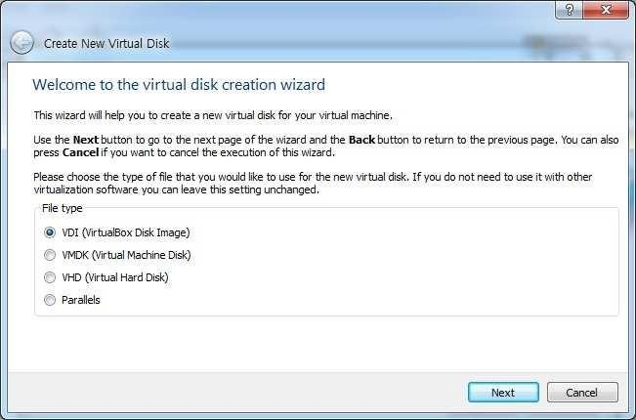

- Choose “DynamicallyAllocated” click continue.
This way, the size of yourVirtual Hard Disk will grow as you use.

PC

I2. Click the folder icon and choose the ubuntu iso file you downloaded.

I3. Select the size of the Virtual Disk (I recommend choosing 8 GB) and click continue

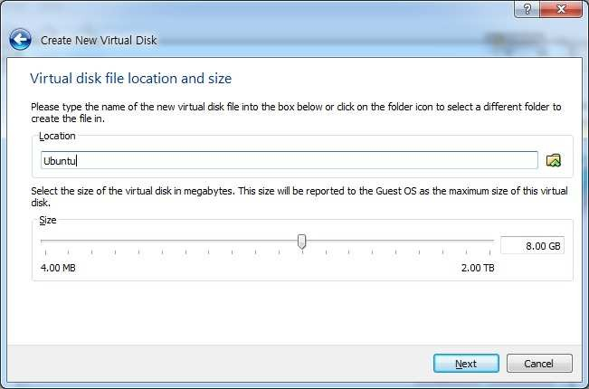
PC

I4. ClickCreate

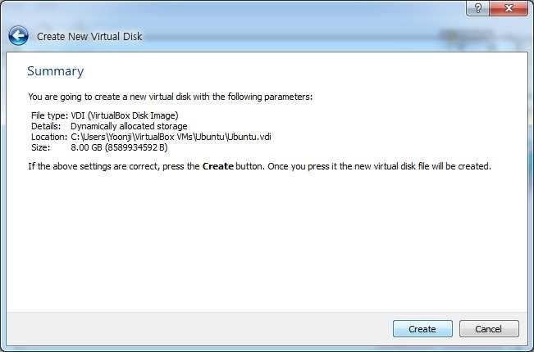

Exno.4.a : C Programming on Linux
- OpenTerminal(Applications-Accessories-Terminal)

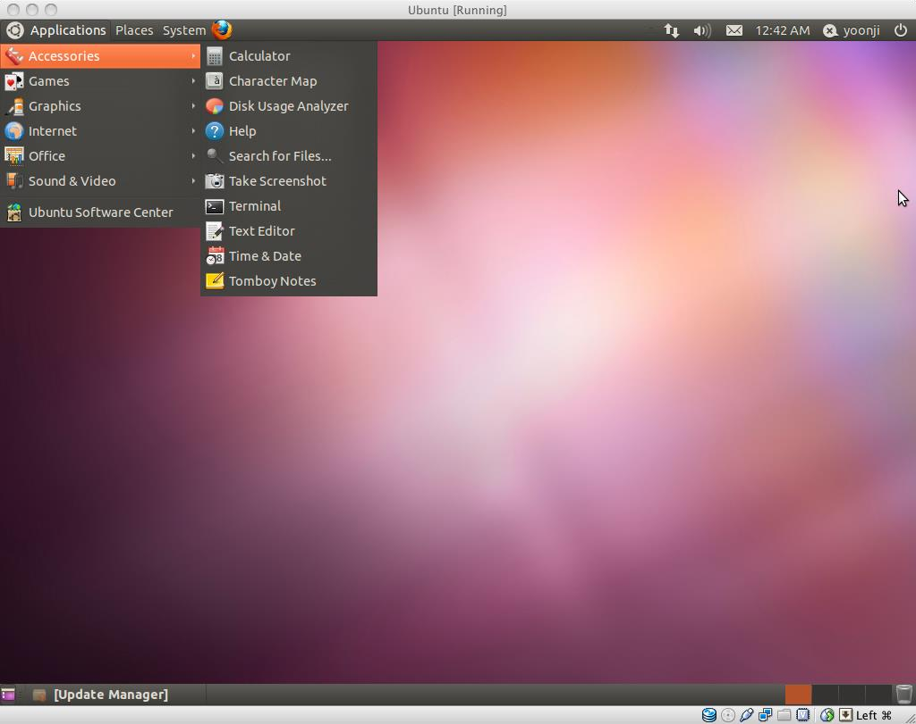

- Open gedit by typing “gedit &” onterminal
(You can also use any other Text Editor application)

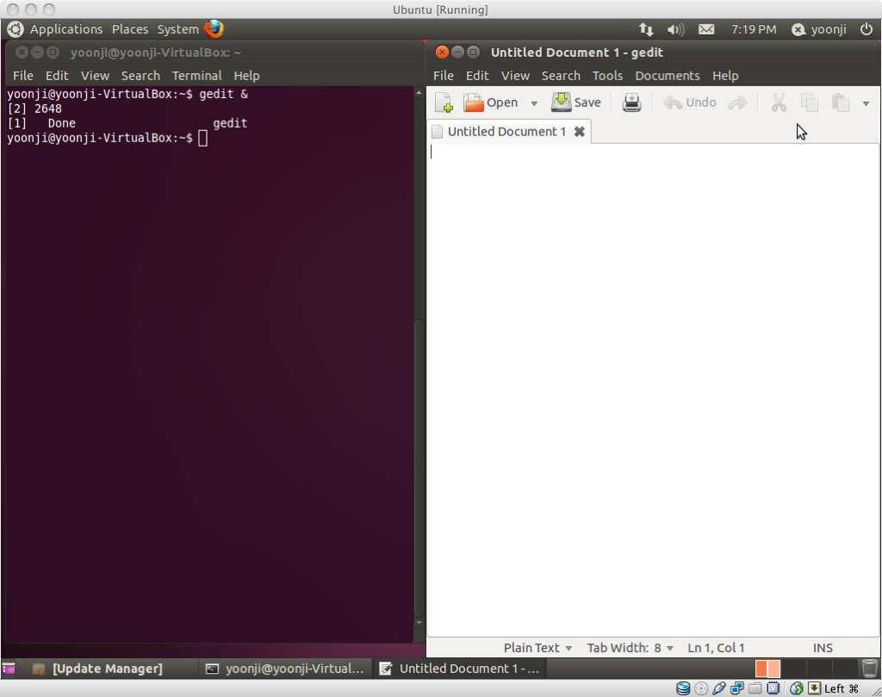
- type program as

#include<stdio.h>
main()

{
printf(“helloworld \n”);
}
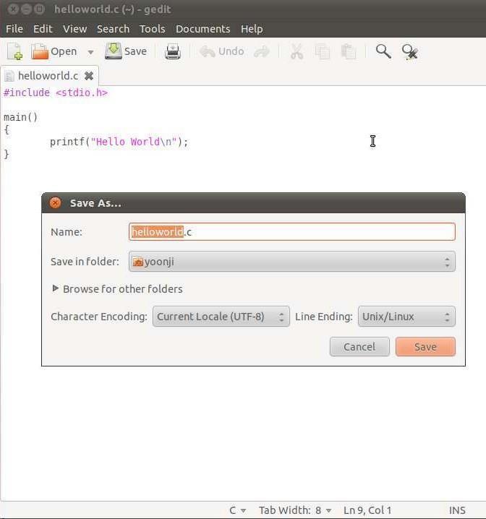

save it as helloworld.c Type“ls” on Terminal to see all files under currentfolder
- Confirm that “helloworld.c” is in the currentdirectory. Ifnot,type
- cd DIRECTORY_PATH to go to the directory that has “helloworld.c”
- Type“gcc helloworld.c” to compile, and type “ls” to confirm that a new executable file “a.out” iscreated
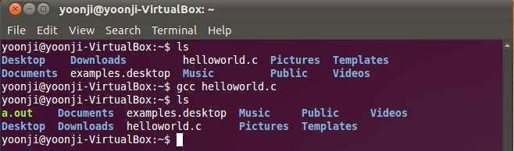

- Type“./a.out” on Terminal to run theprogram

- If you see “HelloWorld” on the next line,
you just successfully ran your first C program!

- Try other codes from “A Shotgun Introduction to C” on professor Edwards’s webpage.You can also find many C programing guides online. (jusgoogleit!)

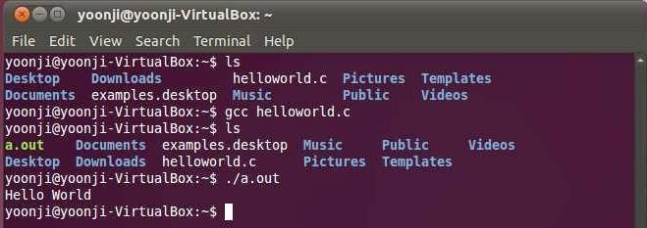

Result:
Thus the virtual machine is created and the c program was executed.

Viva questions:
- What is GCC?
- How do you install GCC on Ubuntu?
- What is the structure of a simple C program?
- How can we accept input from the user in C?
- What is an object file in C compilation?

EX NO:5 Create an Amazon EC2 Instance

In the search box search for EC2 then select it

Zoom image will be displayed

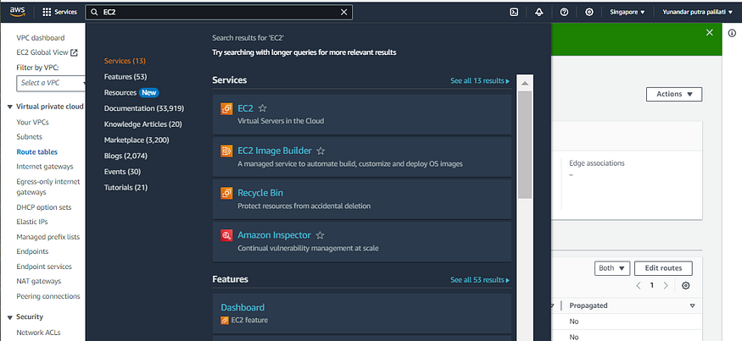

On the dashboard page, click the Launch instance button. We will be directed to the EC2 instance setting page.

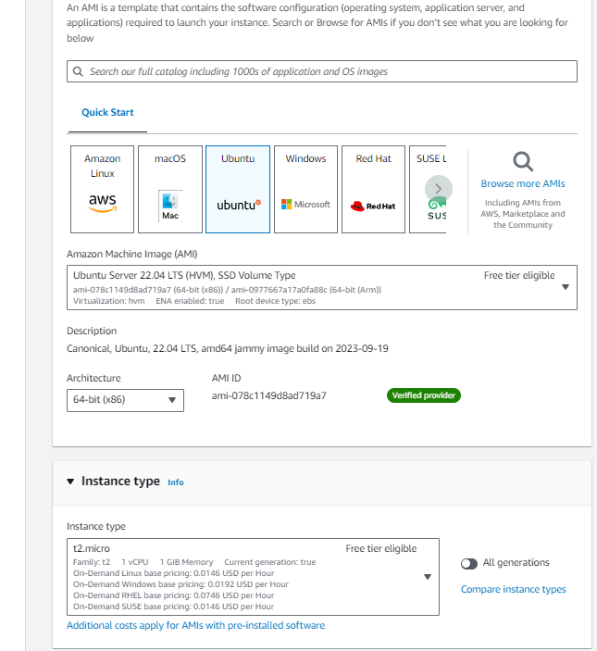

In the AMI (Amazon Machine Image) template, select Ubuntu. We choose the instance type t2.micro because it is free as learning material, for the key pair we choose proceed without a key pair

Next we will set the Network settings to connect to the VPC. In previous article, I had shown how to create VPC

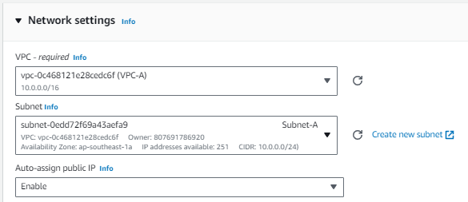

Enable auto-assign public IP so it can access in internet

In the Firewall section, we set it as this

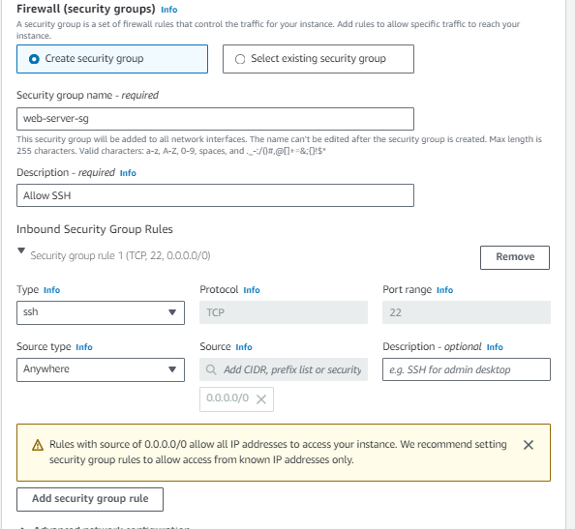

We will set it so that all IP addresses can access EC2 via SSH

For storage, because we don’t need a lot of storage, just set it to 8 GB

If so, click Launch instance. This is how the instance we have created looks like

Zoom image will be displayed

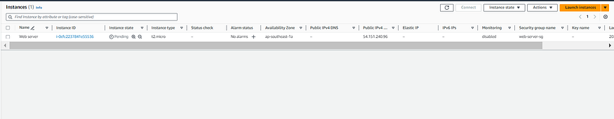

Setting up a Web Server

In this section we will try operating an EC2 instance, cloning a GitHub repository, and running a web server.

First, go to the EC2 instance page, then check the web server that we just created. Click the connect button

Zoom image will be displayed

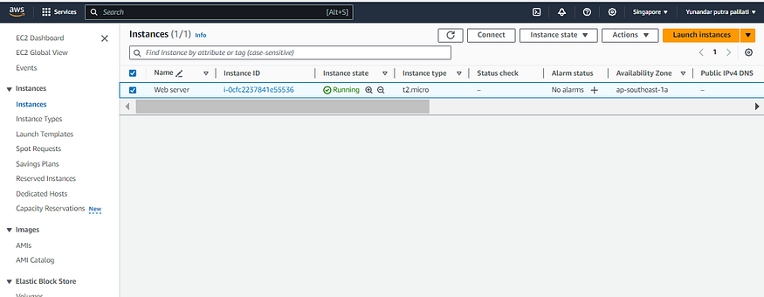

If we click, we are directed to the Connect to instance page. We can specify our username and can see our public IP. Click the Connect button

Zoom image will be displayed

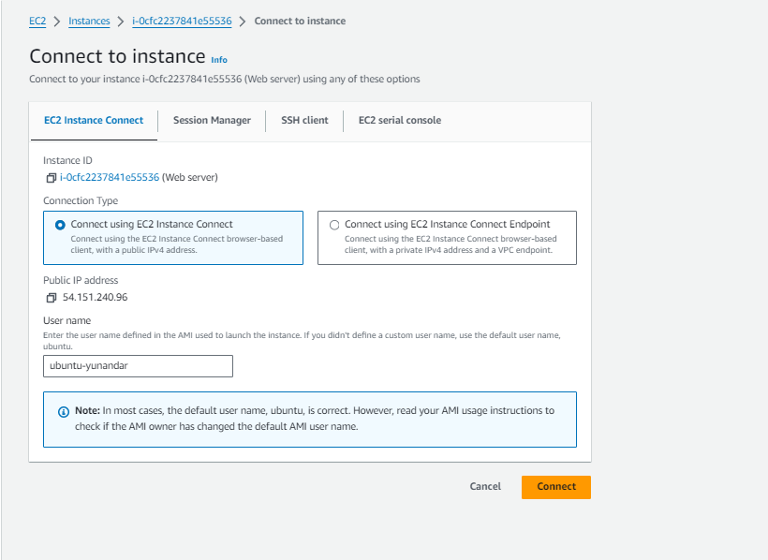

We will be directed to a new tab and display the console of our EC2 instance

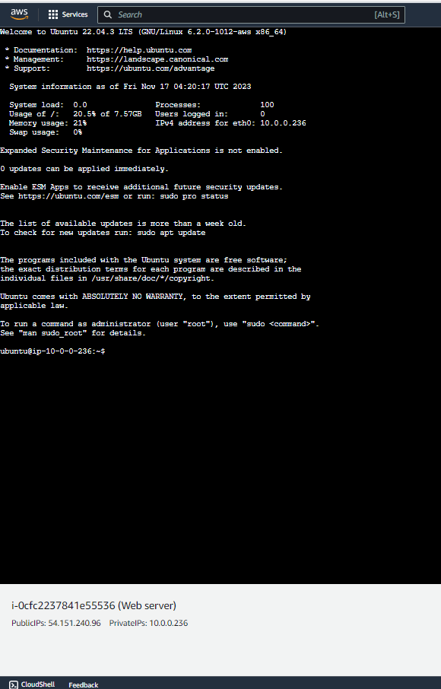

Next, let’s try running the github repository clone command with the git clone command

git clone https://github.com/dicodingacademy/a387-jarkom-labs.git

Zoom image will be displayed

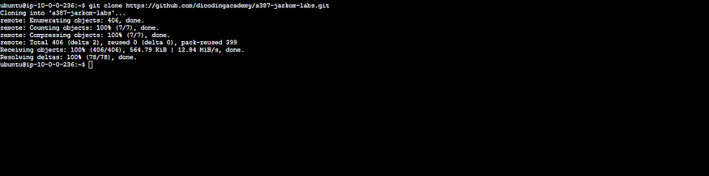

Then go to the folder that we cloned using the command cd

The next step, to run a web server we need Node.js. To make it easier to set the Node.js version on an Ec2 instance, we will use a tool called nvm. To install nvm on ubuntu, run the command

curl -o- https://raw.githubusercontent.com/nvm-sh/nvm/v0.37.2/install.sh | bash

Once installed, we first exit EC2 with the exit command, then connect again via the EC2 Instance page

After logging in again, install Node.js with the command

nvm install v14.15.4

Zoom image will be displayed

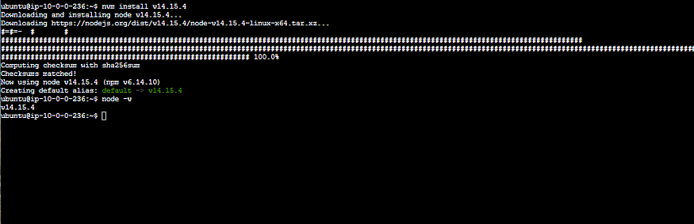

Node.js installed successfully!

Then we will install dependencies. Enter the a387 directory. then run the commands npm install and npm run start

Testing the Web Server

To test the Web Server that we have created, try opening a new tab and typing http://<public-ip-address>:80/ . We can find our public ip at the bottom of the EC2 instance

If we try, the web server will fail to connect

Zoom image will be displayed

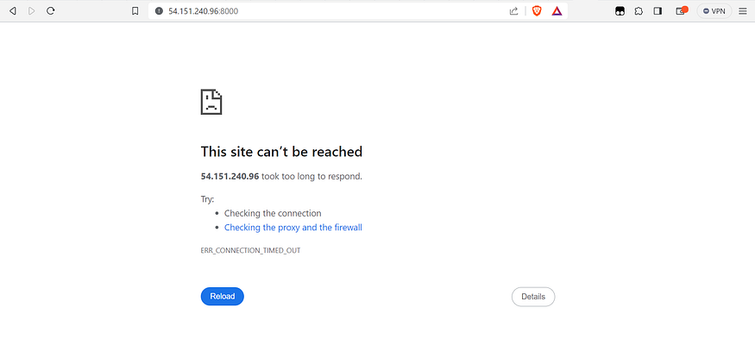

This is because we have not set the firewall so that it can be accessed

Setup Security Group

Go to the EC2 dashboard, then enter the instance menu on the left. Check the web server, open the Security tab at the bottom and click the security group name web-server-sg

Zoom image will be displayed

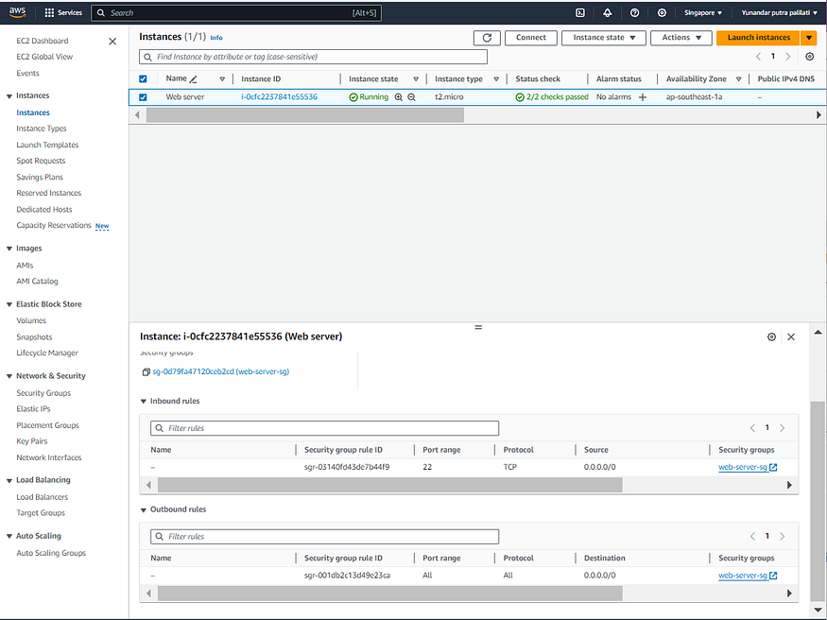

We will enter the Security Groups page. Scroll down and click the Inbound rules tab. Then click the edit inbound rules button

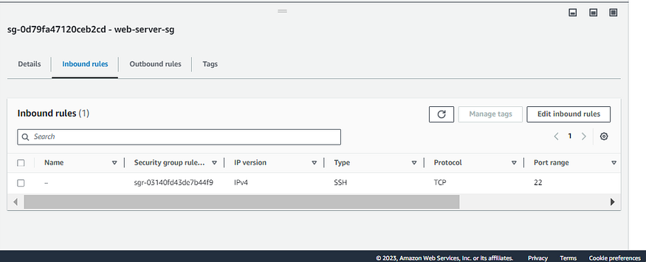

On the Edit inbound rules page, click Add rule. After that, select Custom TCP for the Type column, 80 (as used by the web server) for the Port range Anywhere-IPv4 for the Source section. If so, don’t forget to click Save rules.

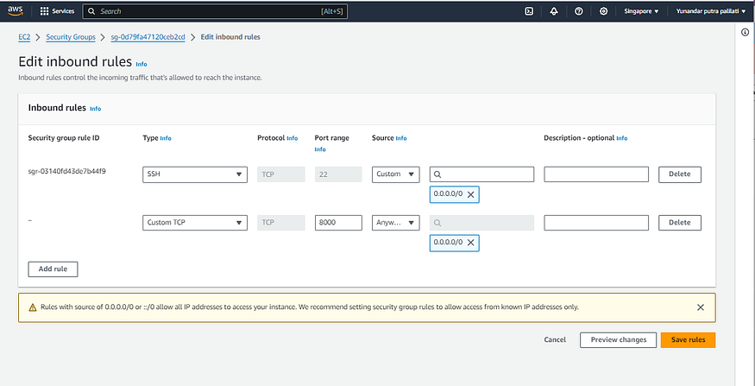

Go back to the instance menu then connect again. Then go to the a387 directory then run the command npm run start. Try to access the public ip in new tab with http://<public-ip>:80

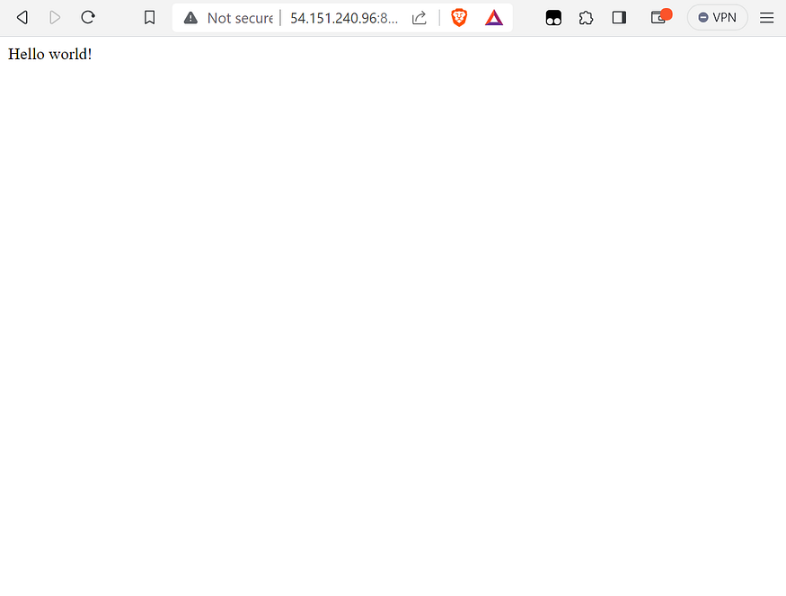

Viva questions:

What is Amazon EC2?

What instance type did you use and why?

What is a key pair used for in EC2?

Why is port 80 allowed in the security group?

Ex no 7: Installing and Running the Google App Engine on Windows

Aim:

To perform the installation of the Google App Engine Software Development Kit (SDK) on a Microsoft Windows and running a simple “hello world” application.

Procedure:

- The App Engine SDK allows you to run Google App Engine Applications on your local computer. It simulates the run--‐time environment of the Google App Engine infrastructure.

Step1: To install python
Pre--Requisites: Python 2.5.4

If you don't already have Python 2.5.4 installed in your computer, download and Install Python 2.5.4 from:

http://www.python.org/download/releases/2.5.4/

Step 2: to install Google App Engine Download and Install
You can download the Google App Engine SDK by going to: http://code.google.com/appengine/downloads.html and download the appropriate installpackage.

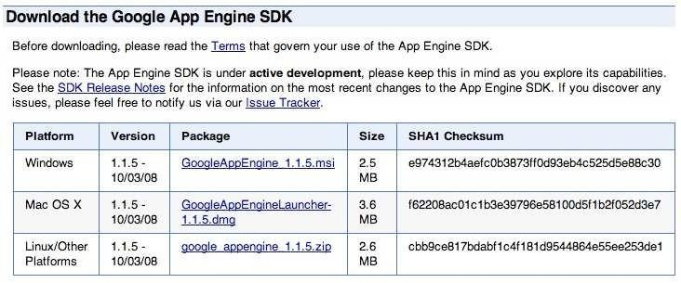

Download the Windows installer – the simplest thing is to download it to your Desktop or another folder that you remember.
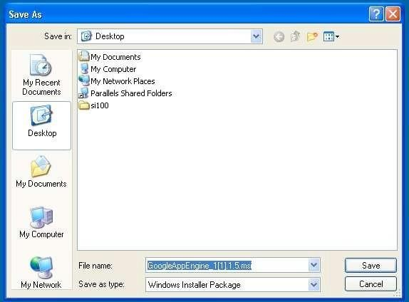
Double Click on the GoogleApplicationEngine installer.

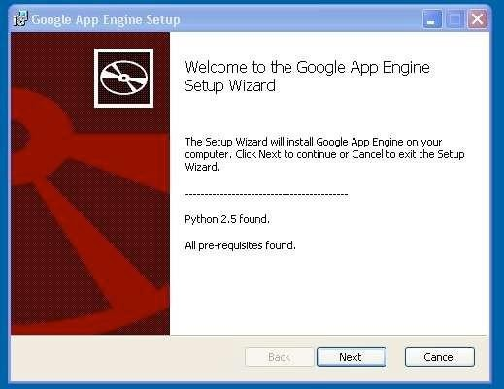

Click through the installation wizard, and it should install the App Engine. If you do not have Python 2.5, it will install Python 2.5 as well.

Once the install is complete you can discard the downloaded installer After installation Google app engine looks that,
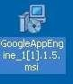

Step 3: Making of the FirstApplication

Now we need to create a simple application. We could use the “+” option to have the launcher make us an application – but instead we will do it by hand to get a better sense of what is goingon.

Make a folder for your Google App Engine applications. I am going to make the Folder on my Desktop called “apps” – the path to this folder is:

C:\Documents and Settings\csev\Desktop\apps

And then make a sub--‐folder in within apps called “ae--01--trivial”–the path to this folder would be:

C:\ Documents and Settings \csev\Desktop\apps\ae--01--trivial
Using a text editor such as JEdit (www.jedit.org), create a file called app.yaml in the
ae--01--trivial folder with the following
contents: application: ae-01-
trivial version: 1 runtime: python api_version: 1 handlers:
- url: /.*
script: index.py

Then create a file in the ae--01--trivial folder called index.py with three lines in it:

print 'Content- Type:text/plain' print ' ' print 'Hello there Chuck'

Step 4: Run the program

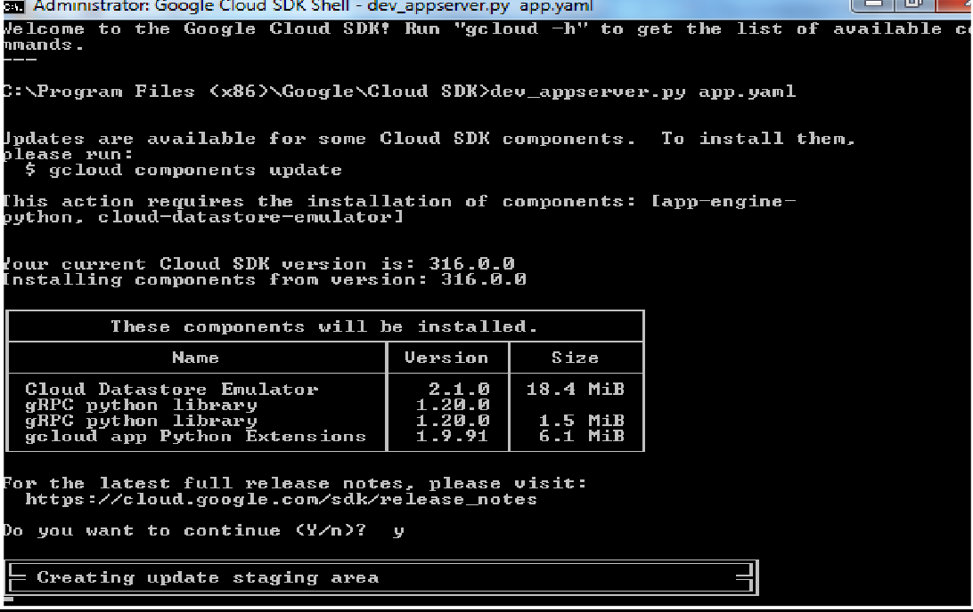

Output:
Once you have selected your application and press Run. After a few moments your application will start and the launcher will show a little green icon next to your application. Then press Browse to open a browser pointing at your application which is running at http://localhost:8080/

Paste http://localhost:8080 into your browser and you should see your application as follows:
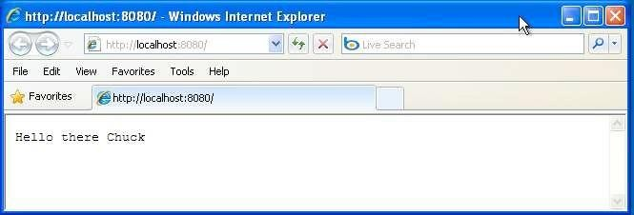

Result:

Thus the python application program was executed

VIVA QUESTIONS:
- What is Google App Engine (GAE)?
- What is the difference between Standard and Flexible environment in GAE?
- How do you deploy a Java app to App Engine?
- How do you open the deployed app in the browser?

EXP NO 8: Setup Web Server Over Docker Container in Linux

Before setting up a server we must know the real meaning or definition of a server. So, the Server is a program that provides the client with any kind of services. For example, a web server provides our websites, a database server provides us data. This means every server has work to do and for every different work we want them to do, we have to choose different servers. For knowing more about servers and their working click here. To check more about dockers - click here.

Pre-requisite:

Linux Operating system Like Ubuntu, Redhat, Kali Linux.

Internet connectivity

Docker installed on system

What we are going to do VISUAL:

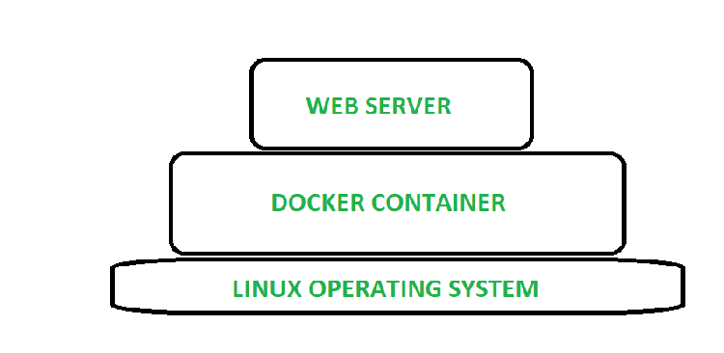

Let's now understand the installation and configuration.

3 steps to configure a Web Server

Install the Server Program

Configuration of Server

Start the server

Installing the Server Software

Start docker services.

systemctl start docker

Open the docker container, you can use centos 7 images to launch.If you don't have centos images you can download it from the www.hub.docker.com

docker run -it --network host centos:7

We are going to use HTTPD server.It could be installed using YUM command and DNF if you are using RHEL 8.

yum install httpd

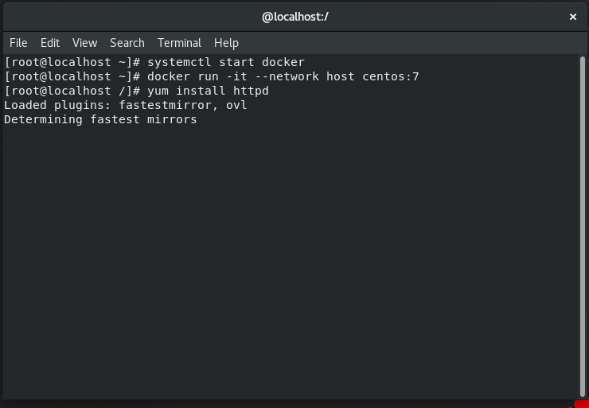webserver installation

Configuring the Web server

Actually the server is already been configured and now its the time to update or make a website over this server.Server website can be accessed using the IP address of the host. Setup website

cd /var/www/html/

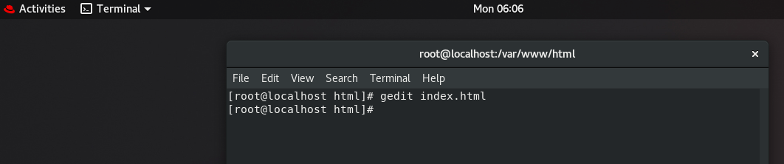In this directory you could save your website and it would be available over the network.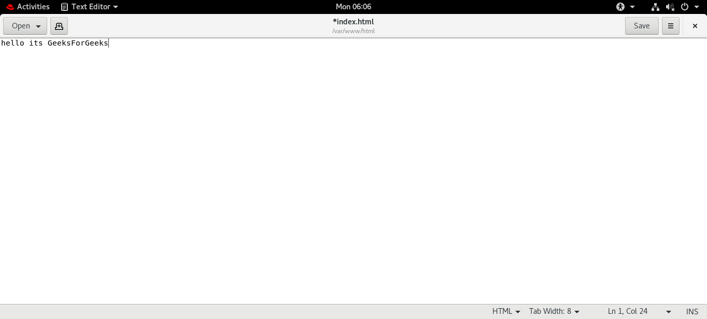

Start the server

systemctl start httpd

If this doesn't start the server, try this

/usr/sbin/httpd

Access the content of website

To access the content of the webserver you must know the ip address, which could be known using "ifconfig" command.And then do the further steps.

curl http://IP of host/page_name.html

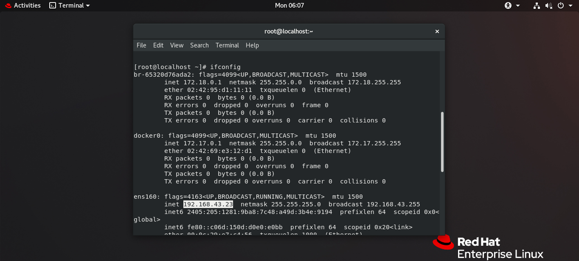

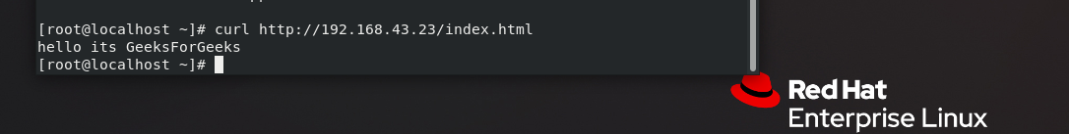

1. Create a host directory to map

bash

CopyEdit

mkdir -p ~/mywebdata

echo "<h1>Hello from Apache in Docker!</h1>" > ~/mywebdata/index.html

2. Create a Dockerfile

Dockerfile

CopyEdit

# Dockerfile

FROM ubuntu:20.04

RUN apt-get update && \

apt-get install -y apache2 && \

apt-get clean && \

rm -rf /var/lib/apt/lists/*

EXPOSE 80

CMD ["/usr/sbin/apache2ctl", "-D", "FOREGROUND"]

3. Build the image

bash

CopyEdit

docker build -t apache-webserver .

4. Run the container with volume mapping

bash

CopyEdit

docker run -d -p 8080:80 -v ~/mywebdata:/var/www/html apache-webserver

✅ Now open your browser and visit http://localhost:8080 — you should see the HTML content from ~/mywebdata/index.html.

RESULT:

VIVA QUESTIONS:

What is Docker?

Explain port mapping in Docker.

What is Apache2?

What is the role of app.route() in Flask?

Why do we use volume mapping with Docker containers?

Exno 9: File Transfer from one virtual machine to another virtual machine Aim:
To find a procedure to transfer the files from one virtual machine to another virtual machine.

Procedure:

Method1: Creating a Shared Folder in VirtualBox

A shared folder is a folder which makes its files available on both the guest machine and the host machine at the same time. Creating a shared folder between the guest and the host allows you to easily manage files which should be present on both machines. The course virtual machines are ready to use shared folders right away, but if you are using the virtual machine on your personal computer you will need to specify which folder to use as shared storage.

Shared Folders on SCS Lab Computers using Course VMs:

If you are using a course VM on a lab computer, it is likely that a shared folder has already been setup for you. On the desktop of your course VM you should notice a folder titled SharedFolders. Inside of this you will find any folders that have been shared between the course VM and lab computers.
You should see two folders that have already been configured for you: Z_DRIVE and Temp.
Z_DRIVE gives you access to your Windows Account Z:\ drive. This is storage that is persistent to your SCS account and available as a network drive on the lab computers.
Temp gives you access to the folder found at D:\temp on the lab computer. Files stored in this folder are local to the machine, meaning that they can be accessed faster, but will delete from the system when you log out.

If you are working with data that you will need to use again, use the Z_DRIVE for your shared folder. If you need faster read/write speed, use the Temp folder, but remember to backup your files or they will be deleted when you log off the computer.

Shared Folders on Personal Computers:

If you are using your own personal machine, you will need to configure VirtualBox to look in the right place for your shared files.

First, click on the guest machine you intend to share files with. From there, you can select the guestSettings and navigate to Shared Folders on the left side menu. To create a new shared folder, either click the New Folder icon on the right menu or right click the empty list of shared folders and click Add Shared Folder. From here, there are six options:

- Folder Path: The folder name on the host machine. Click the drop down menu and navigate to the folder you would like to share.
- Folder Name: This is the name of the folder as it will appear on the guest machine.

- Read-Only: If you check read-only, the guest machine will be unable to write changes to the folder. This is valuable when you only want to send files to the virtual machine, but do not want to risk having the files modified by the guest.
- Auto-Mount: When any external storage is connected to a computer it must be mounted in order to be used. It is recommended that you turn on auto-mounting, unless you are familiar with the process of mounting a drive yourself.
- Mount Point: Unless you already know about mount points, leave this blank.

- Make Permanent: If you check this, the shared folder will be a permanent machine folder. If it is not checked, the folder will not be shared after a shutdown.
On the course virtual machines, when you load into the desktop, you should see a folder labelledSharedFolders. In there you will see any folders that are currently mounted and being shared.

Steps:

  - Select the guest machine you wish to share files with

Click Settings > Shared Folders
  - Right-click and select Add Shared Folder and use the following settings:

Folder Path: Click the dropdown arrow, select Other, and navigate to the folder you would like to share
Folder Name: Anything to identify it on the guest machine
Read-Only: Unchecked (Checked, if you are exclusively pulling files from the host) Auto-Mount: Checked
Mount Point: Leave blank
  - Click OK

Method 2: Dragging and Dropping Files in VirtualBox

If you only need to transfer a few files quickly, you can simply drag and drop the files in. On the top bar of the running guest machine, click on Devices > Drag and Drop and make sure that Bidirectional is selected. This means that you will be able to drag files from the host to the guest and from the guest to the host. Once bidirectional drag and drop is checked, you should be able to begin dragging and dropping files.
NOTE: Sometimes when dragging files into the course VM, you may not be able to drag into the file browser directly. If you encounter this issue, you should drag your files onto the Desktop and move the files around from there. You should see the cursor change when it is ready to drop files.
You can also drag files from the guest machine into the host. To do this, simply open the file browser on the host to where you would like to drop the files and drag the files from the virtual machine into the file browser of the host. File transfers should be pretty quick; if the virtual machine seems stuck when transferring, simply cancel the transfer and try again.

Method 3: Managing Files with NextCloud

On any virtual machine, including VirtualBox, VMWare, or the virtual machines hosted on the SCS OpenStack, you can access the SCS NextCloud services to move files between multiple machines and your SCS Windows Account storage. NextCloud offers you all of your SCS storage in one remote location, similar to how you might use other file hosting services like Dropbox or Google Drive. Before trying to use NextCloud, you should check that you can access the service by logging in here.
If you can access the NextCloud services, you can browse the various file storage services available to you:

- Linux Home: These are the files from your SCS Linux Account

- Windows Home: These are the files from your SCS Windows Account and your lab Z:\ drive.

- NextCloud: In addition to the other storage accounts provided to you by the SCS, you can also upload up to 20GB of files directly to NextCloud.
With NextCloud, you can upload your files from any machine with an internet connection and download them onto any other machine with an internet connection. For example, you can move project files off of your virtual machine, onto the NextCloud storage, and then download them on your personal laptop.

Alternatively, you can upload files from your personal PC onto the NextCloud storage, place it into theWindows Home folder, and access those files from either the lab Z:\ drive or download them on a virtual machine like VirtualBox or OpenStack.

Uploading Files to NextCloud from a Lab Computer:

If you would like to upload files from a lab computer, the easiest way to do this is to place the files you would like to transfer into your Z:\ drive. These files will be automatically backup into your NextCloud storage under the Windows Home folder. After that, you can move them into the main NextCloud storage or choose to keep them in your Z:\drive.

Uploading Files to NextCloud from a VM or Other PC:

If you would like to upload files from either a VM or any other computer, you can login to the NextCloud service using any of the available interfaces, such as the web interface. Press the “+” icon in the top left of the file browser and select Upload File. From here, you can choose to keep it in the main NextCloud storage, move it into your Windows Account storage (the Windows Home folder), or into your Linux Account storage (the Linux Home folder).

Downloading NextCloud Files to a VM or Other PC:

Once your files are uploaded you will be able to download those files onto any machine which can connect to NextCloud. First, log in to your preferred NextCloud interface (eg. the web interface). N to the folder which contains the files you would like to download. Once you are in the target folder, click the checkbox next to each file you would like to download. Above the file listing you should notice the context bar

changing to tell you how many files you have selected and a button labelled Actions. ClickActions > Download.
If you have selected a single file, it will prompt you to confirm the download. If you have chosen more than one file, NextCloud will place all of the selected files into a zip archive. Before you can use the files, you will need to extract them from the archive. Once you have downloaded your file, or extracted your archive, you are ready to use your files on your machine.

Result:
Thus the file is transfered from one virtual machine to another virtual machine.

VIVA QUESTIONS:

What are the common methods to transfer files between two virtual machines?

How do you transfer a file from one VM to another without using a password?

What command is used to copy files from container to host?

Exno 10 :Launch virtual machine using trystack (Online Openstack Demo Version)

Aim:

To find a procedure to launch virtual machine using trystack (Online Openstack Demo Version).

OpenStack is an open-source software cloud computing platform. OpenStack is primarily used for deploying an infrastructure as a service (IaaS) solution like Amazon Web Service (AWS). In other words, you can make your own AWS by using OpenStack. If you want to try out OpenStack, TryStack is the easiest and free way to do it.
In order to try OpenStack in TryStack, you must register yourself by joining TryStack FacebookGroup. The acceptance of group needs a couple days because it’s approved manually. After you have been accepted in the TryStack Group, you can log in TryStack.
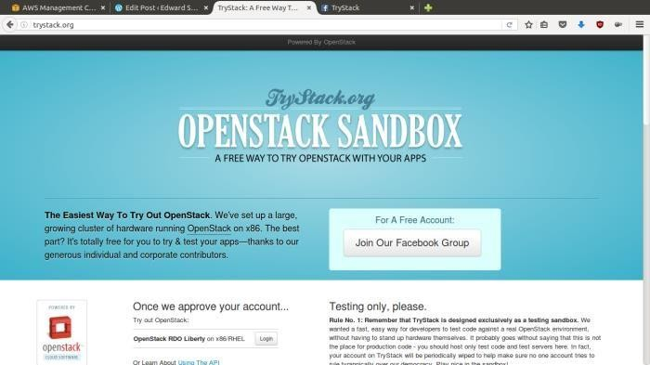
TryStack.org Homepage
I assume that you already join to the Facebook Group and login to the dashboard. After youlog in to the TryStack, you will see the Compute Dashboard like:

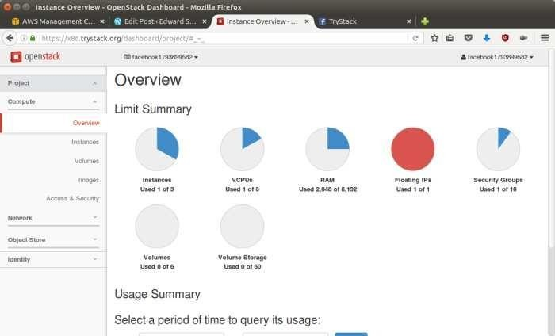
OpenStack Compute Dashboard

Overview: What we will do?

In this post, I will show you how to run an OpenStack instance. The instance will be accessible through the internet (have a public IP address). The final topology will like
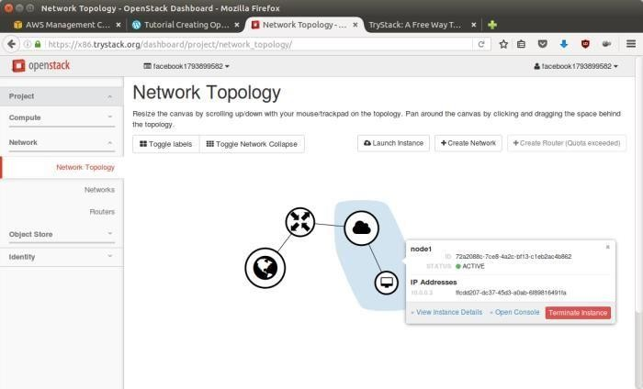

:

Step 1: Create Network

Network? Yes, the network in here is our own local network. So, your instances will be not mixed up with the others. You can imagine this as your own LAN (Local Area Network) in the cloud.
- Go to Network > Networks and then click CreateNetwork.
- In Network tab, fill Network Name for example internal and then clickNext.
- In Subnettab,
  - Fill Network Address with appropriate CIDR, for example 192.168.1.0/24. Use private network CIDR block as the bestpractice.
  - Select IP Version with appropriate IP version, in this caseIPv4.
  - ClickNext.
  - In Subnet Details tab, fill DNS Name Servers with 8.8.8.8 (Google DNS) and then clickCreate.

Step 2: Create Instance
Now, we will create an instance. The instance is a virtual machine in the cloud, like AWS EC2. You need the instance to connect to the network that we just created in the previous step.
- Go to Compute > Instances and then click LaunchInstance.
- In Detailstab,
  - Fill Instance Name, for example Ubuntu1.
  - Select Flavor, for examplem1.medium.
  - Fill Instance Count with1.
  - Select Instance Boot Source with Boot fromImage.
  - Select Image Name with Ubuntu 14.04 amd64 (243.7 MB) if you want installUbuntu
14.04 in your virtual machine.
- In Access & Securitytab,
  - Click [+] button of Key Pair to import key pair. This key pair is a public and private keythat we will use to connect to the instance from ourmachine.
  - In Import Key Pairdialog,
    - Fill Key Pair Name with your machine name (for exampleEdward-Key).

    - Fill Public Key with your SSH public key (usually is in ~/.ssh/id_rsa.pub). See description in Import Key Pair dialog box for more information. If you are using Windows, you can use Puttygen to generate keypair.
    - Click Import keypair.
  - In Security Groups, mark/checkdefault.
  - In Networkingtab,
    - In Selected Networks, select network that have been created in Step 1, for exampleinternal.
  - ClickLaunch.
  - If you want to create multiple instances, you can repeat step 1-5. I created one more instance with instance name Ubuntu2.

Step 3: Create Router

I guess you already know what router is. In the step 1, we created our network, but it is isolated. It doesn’t connect to the internet. To make our network has an internet connection, we need a router that running as the gateway to the internet.

- Go to Network > Routers and then click CreateRouter.
- Fill Router Name for example router1 and then click Createrouter.
- Click on your router name link, for example router1, Router Detailspage.
- Click Set Gateway button in upperright:
  - Select External networks withexternal.
  - ThenOK.
- Click Add Interfacebutton.
  - Select Subnet with the network that you have been created in Step 1.
  - Click Addinterface.
- Go to Network > Network Topology. You will see the network topology. In the example, there are two network, i.e. external and internal, those are bridged by a router. Thereare
instances those are joined to internal network.

Step 4: Configure Floating IP Address
Floating IP address is public IP address. It makes your instance is accessible from the internet. When you launch your instance, the instance will have a private network IP, but no public IP. In OpenStack, the public IPs is collected in a pool and managed by admin (in our case is TryStack).

You need to request a public (floating) IP address to be assigned to your instance.
- Go to Compute >Instance.
- In one of your instances, click More > Associate FloatingIP.
- In IP Address, click Plus[+].
- Select Pool to external and then click AllocateIP.
- ClickAssociate.
- Now you will get a public IP, e.g. 8.21.28.120, for yourinstance.

Step 5: Configure Access & Security
OpenStack has a feature like a firewall. It can whitelist/blacklist your in/out connection. It is called Security Group.
- Go to Compute > Access & Security and then open Security Groupstab.
- In default row, click ManageRules.
- Click Add Rule, choose ALL ICMP rule to enable ping into your instance, and then clickAdd.
- Click Add Rule, choose HTTP rule to open HTTP port (port 80), and then clickAdd.
- Click Add Rule, choose SSH rule to open SSH port (port 22), and then clickAdd.
- You can open other ports by creating newrules.

Step 6: SSH to Your Instance

Now, you can SSH your instances to the floating IP address that you got in the step 4. If you are using Ubuntu image, the SSH user will be ubuntu.

Result:
Thus the virtual machine is launched using trystack.

VIVA QUESTIONS:

What is OpenStack?

What is an image in OpenStack?

How do you connect to an instance in OpenStack?

What are the components required to launch a VM?

Exno 11 a : Install Hadoopsingle node cluster

Aim:
To Install Hadoopand create thesingle node cluster.

Step 1: To download the Java 8 Package. Save this file in your home directory.

Step 2: Extract the Java Tar File.

Command: tar -xvf jdk-8u101-linux-i586.tar.gz
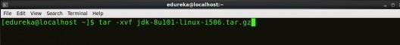

Fig: Hadoop Installation – Extracting Java Files

Step 3: Download the Hadoop 2.7.3 Package.

Command:wget https://archive.apache.org/dist/hadoop/core/hadoop-2.7.3/hadoop-
2.7.3.tar.gz
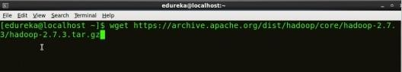

Fig: Hadoop Installation – Downloading Hadoop

Step 4: Extract the Hadoop tar File.

Command: tar -xvf hadoop-2.7.3.tar.gz

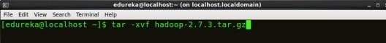

Fig: Hadoop Installation – Extracting Hadoop Files

Step 5: Add the Hadoop and Java paths in the bash file (.bashrc). Open. bashrc file. Now, add Hadoop and Java Path as shown below.
Command: vi .bashrc

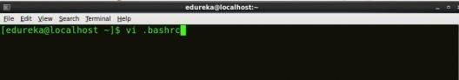
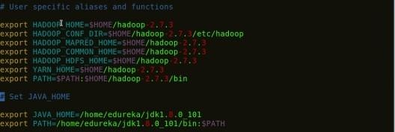

Fig: Hadoop Installation – Setting Environment Variable
Then, save the bash file and close it.

For applying all these changes to the current Terminal, execute the source command.

Command: source .bashrc
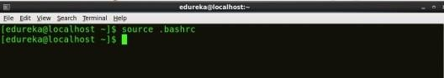

Fig: Hadoop Installation – Refreshing environment variables

To make sure that Java and Hadoop have been properly installed on your system and can be accessed through the Terminal, execute the java -version and hadoop version commands.

Command: java -version
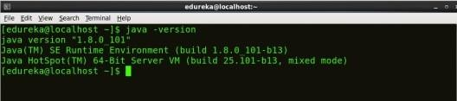
Fig: Hadoop Installation – Checking Java Version Command: hadoop version
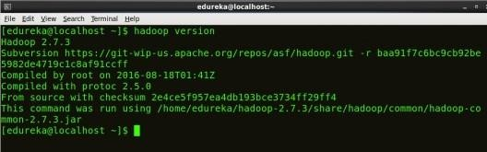

Fig: Hadoop Installation – Checking Hadoop Version

Step 6: Edit the Hadoop Configuration files.

Command: cd hadoop-2.7.3/etc/hadoop/

Command: ls

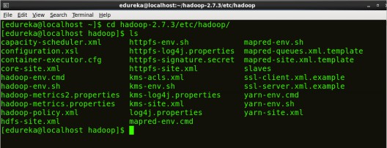
ll the Hadoop configuration files are located in hadoop-2.7.3/etc/hadoop directory as you can see in the snapshot below:

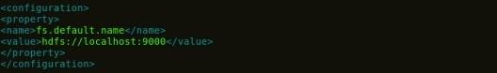

Fig: Hadoop Installation – Hadoop Configuration Files

Step 7: Open core-site.xml and edit the property mentioned below inside configuration tag:

core-site.xml informs Hadoop daemon where NameNode runs in the cluster. It contains configuration settings of Hadoop core such as I/O settings that are common to HDFS & MapReduce.

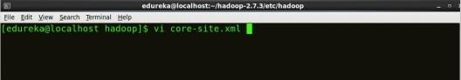
Command: vi core-site.xml

Fig: Hadoop Installation – Configuring core-site.xml
1
2
3
4
5
6
7
8
<?xmlversion="1.0"encoding="UTF-8"?>
<?xml-stylesheettype="text/xsl"href="configuration.xsl"?>
<configuration>
<property>
<name>fs.default.name</name>
<value>hdfs://localhost:9000</value>
</property>
</configuration>

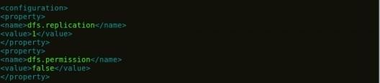
Step 8: Edit hdfs-site.xml and edit the property mentioned below inside configuration tag:

hdfs-site.xml contains configuration settings of HDFS daemons (i.e. Name Node, Data Node, Secondary NameNode). It also includes the replication factor and block size of HDFS.

Command: vi hdfs-site.xml

Fig: Hadoop Installation – Configuring hdfs-site.xml

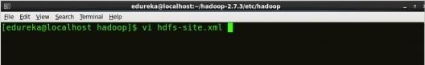

1
2
3
4
5
6
7
8
9
<?xmlversion="1.0"encoding="UTF-8"?>
<?xml-stylesheettype="text/xsl"href="configuration.xsl"?>
<configuration>
<property>
<name>dfs.replication</name>
<value>1</value>
</property>
<property>
<name>dfs.permission</name>

Step 9: Edit the mapred-site.xml file and edit the property mentioned below inside configuration tag:
mapred-site.xml contains configuration settings of MapReduce application like number of JVM that can run in parallel, the size of the mapper and the reducer process, CPU cores available for a process,etc.
In some cases, mapred-site.xml file is not available. So, we have to create the mapred- site.xml file using mapred-site.xml template.
Command: cp mapred-site.xml.template mapred-site.xml
Command: vi mapred-site.xml.
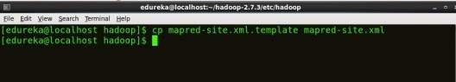
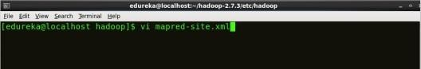
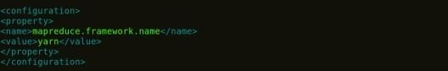

Fig: Hadoop Installation – Configuring mapred-site.xml

1
2
3
4
5
6
7
8
<?xmlversion="1.0"encoding="UTF-8"?>
<?xml-stylesheettype="text/xsl"href="configuration.xsl"?>
<configuration>
<property>
<name>mapreduce.framework.name</name>
<value>yarn</value>
</property>
</configuration>

Step 10: Edit yarn-site.xml and edit the property mentioned below inside configuration tag:

yarn-site.xml contains configuration settings of ResourceManager and NodeManager like application memory management size, the operation needed on program & algorithm, etc.

Command: vi yarn-site.xml
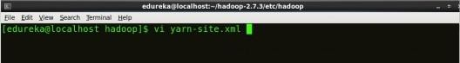
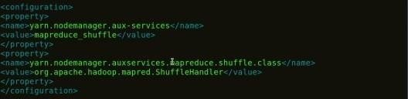

Fig: Hadoop Installation – Configuring yarn-site.xml

1
2
3
4
5
6
7
8
9
1
0
1
1
<?xmlversion="1.0">
<configuration>
<property>
<name>yarn.nodemanager.aux-services</name>
<value>mapreduce_shuffle</value>
</property>
<property>
<name>yarn.nodemanager.auxservices.mapreduce.shuffle.class</ name>
<value>org.apache.hadoop.mapred.ShuffleHandler</value>
</property>
</configuration>

Step 11: Edit hadoop-env.sh and add the Java Path as mentioned below:

hadoop-env.sh contains the environment variables that are used in the script to run Hadoop like Java home path, etc.

Command: vi hadoop–env.sh
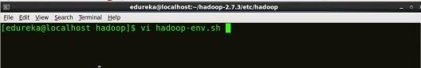

Fig: Hadoop Installation – Configuring hadoop-env.sh

Step 12: Go to Hadoop home directory and format the NameNode.
Command: cd
Command: cd hadoop-2.7.3
Command: bin/hadoop namenode -format
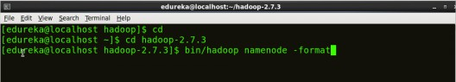

Fig: Hadoop Installation – Formatting NameNode

This formats the HDFS via NameNode. This command is only executed for the first time. Formatting the file system means initializing the directory specified by the dfs.name.dir variable.

Never format, up and running Hadoop filesystem. You will lose all your data stored in theHDFS.

Step 13: Once the NameNode is formatted, go to hadoop-2.7.3/sbin directory and start all the daemons.

Command: cd hadoop-2.7.3/sbin

Either you can start all daemons with a single command or do it individually.

Command: ./start-all.sh

The above command is a combination of start-dfs.sh, start-yarn.sh &mr-jobhistory- daemon.sh
Or you can run all the services individually as below:

Start NameNode:
The NameNode is the centerpiece of an HDFS file system. It keeps the directory tree of all files stored in the HDFS and tracks all the file stored across the cluster.
Command: ./hadoop-daemon.sh start namenode

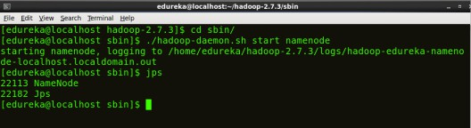
StartDataNode:
– Starting NameNode
On startup, a DataNode connects to the Namenode and it responds to the requests from the Namenode for differentoperations.

Command: ./hadoop-daemon.sh start datanode

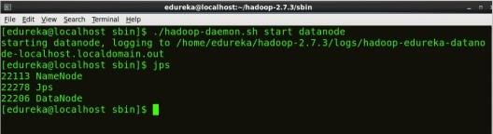

Fig: Hadoop Installation – Starting DataNode
Start ResourceManager:
ResourceManager is the master that arbitrates all the available cluster resources and thus helps in managing the distributed applications running on the YARN system. Its work is to manage each NodeManagers and the each application’s ApplicationMaster.

Command: ./yarn-daemon.sh start resourcemanager
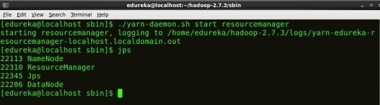

Fig: Hadoop Installation – Starting ResourceManager

Start NodeManager:
The NodeManager in each machine framework is the agent which is responsible for managing containers, monitoring their resource usage and reporting the same to the ResourceManager.

Command: ./yarn-daemon.sh start nodemanager
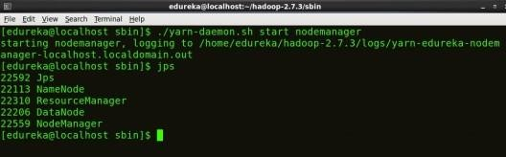

Fig: Hadoop Installation – Starting NodeManager

Start JobHistoryServer:
JobHistoryServer is responsible for servicing all job history related requests from client.
Command: ./mr-jobhistory-daemon.sh start historyserver

Step 14: To check that all the Hadoop services are up and running, run the below command.
Command: jps
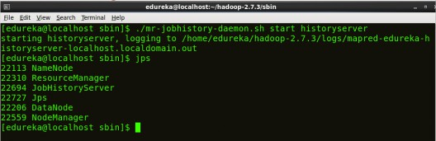

Fig: Hadoop Installation – Checking Daemons

Step 15: Now open the Mozilla browser and go
to localhost:50070/dfshealth.html to check the NameNode interface.
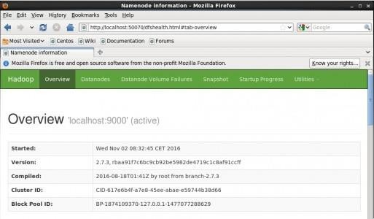

Fig: Hadoop Installation – Starting WebUI

- Congratulations, you have successfully installed a single node Hadoop cluster

Result:
Thus the Hadoop single node cluster was created successfully.

Ex no11 b. Wordcount program to demonstrate the use of Map and Reduce tasks

Aim:
To write a wordcount program to demonstrate the use of Map and Reduce tasks.

Procedure: step1
hduser@nspublin:/usr/local/hadoop/sbin$ mkdir /home/hduser/wc

step2:Compiling the java file - WordCount.java

hduser@nspublin:/usr/local/hadoop/sbin$ sudo /usr/lib/jvm/java-8-oracle/bin/javac -classpath
/home/hduser/hadoop-core-1.2.1.jar -d /home/hduser/wc /home/hduser/WordCount.java

step3:Creating jar file for wordCount.java:
hduser@nspublin:/usr/local/hadoop/sbin$ jar -cvf /home/hduser/wc.jar -C /home/hduser/wc/ . added manifest
adding: WordCount$IntSumReducer.class(in = 1739) (out= 739)(deflated 57%) adding: WordCount$TokenizerMapper.class(in = 1736) (out= 753)(deflated 56%) adding: WordCount.class(in = 1491) (out= 814)(deflated 45%)

step4.Executing jar file for WordCount.java
hduser@ksrietcsevb:/usr/local/hadoop/sbin$ hadoop jar /home/hduser/wc.jar WordCount /user/input
/user/output
Picked up JAVA_TOOL_OPTIONS: -javaagent:/usr/share/java/jayatanaag.jar
16/09/12 10:52:53 WARN util.NativeCodeLoader: Unable to load native-hadoop library for your platform... using builtin-java classes where applicable
Step5: to check the file in Output file hduser@ksrietcsevb:/usr/local/hadoop/sbin$ hadoop fs -ls /user/output Picked up JAVA_TOOL_OPTIONS: -javaagent:/usr/share/java/jayatanaag.jar
16/09/12 10:56:22 WARN util.NativeCodeLoader: Unable to load native-hadoop library for your platform... using builtin-java classes where applicable
Found 2 items

-rw-r--r-- 1 hdusersupergroup 0 2016-09-12 10:56 /user/output/_SUCCESS
-rw-r--r-- 1 hdusersupergroup 182 2016-09-12 10:56 /user/output/part-r-00000

Program:
/home/hduser/WordCount.java:

import java.io.IOException; import java.util.StringTokenizer;
import org.apache.hadoop.conf.Configuration; import org.apache.hadoop.fs.Path;
import org.apache.hadoop.io.IntWritable; import org.apache.hadoop.io.Text;
import org.apache.hadoop.mapreduce.Job; import org.apache.hadoop.mapreduce.Mapper; import org.apache.hadoop.mapreduce.Reducer;
import org.apache.hadoop.mapreduce.lib.input.FileInputFormat; import org.apache.hadoop.mapreduce.lib.output.FileOutputFormat; public class WordCount {
public static class TokenizerMapper
extends Mapper<Object, Text, Text, IntWritable>{ private final static IntWritable one = new IntWritable(1); private Text word = new Text();
public void map(Object key, Text value, Context context ) throws IOException, InterruptedException {
StringTokenizeritr = new StringTokenizer(value.toString()); while (itr.hasMoreTokens()) {
word.set(itr.nextToken()); context.write(word, one); } }
}
public static class IntSumReducer
extends Reducer<Text,IntWritable,Text,IntWritable> { private IntWritable result = new IntWritable();
public void reduce(Text key, Iterable<IntWritable>values,Context context) throws IOException,

InterruptedException { int sum = 0;
for (IntWritableval : values) { sum += val.get();
} result.set(sum); context.write(key, result); } }
public static void main(String[] args) throws Exception { Configuration conf = new Configuration();
Job job = Job.getInstance(conf, "word count"); job.setJarByClass(WordCount.class); job.setMapperClass(TokenizerMapper.class); job.setCombinerClass(IntSumReducer.class); job.setReducerClass(IntSumReducer.class); job.setOutputKeyClass(Text.class); job.setOutputValueClass(IntWritable.class); FileInputFormat.addInputPath(job, new Path(args[0])); FileOutputFormat.setOutputPath(job, new Path(args[1])); System.exit(job.waitForCompletion(true) ? 0 : 1); }
}

Input:
hai i am in gcc lab

Output
hduser@ksrietcsevb:/usr/local/hadoop/sbin$ hadoop fs -cat /user/output/*
Picked up JAVA_TOOL_OPTIONS: -javaagent:/usr/share/java/jayatanaag.jar
16/09/12 10:56:32 WARN util.NativeCodeLoader: Unable to load native-hadoop library for your platform... using builtin-java classes where applicable
am | 1
gcc | 1
hai | 1
i | 1
in | 1
lab | 1
hduser@ksrietcsevb:/usr/local/hadoop/sbin$

Result:
Thus the word count program was executed using hadoop mar reduce function.
Viva questions:
- What is Hadoop?
- Which daemons run in a single-node setup?
- . What are the phases in WordCount MapReduce?

How do you copy files from local to HDFS?

Exno 12:

We will use the following steps to deploy Flask microservice as a Serverless Function in OpenFaas:

Setting up Kubernetes and OpenFaas

Dockerizing Flask Application

Creating a Custom Function

Deploying the Function

Testing the Function

Prerequisites

Kubernetes cluster: We will need a running Kubernetes cluster. In case Kubernetes Cluster is not available then follow the instructions to Set Up a Kubernetes Cluster.

Docker Hub Account: An account at Docker Hub for storing Docker images that we will create during this tutorial. Refer to the Docker Hub page for details about creating a new account.

kubectl: Refer to Install and Set Up kubectl page for details about installing kubectl.

1. Setting up Kubernetes and OpenFaas

OpenFaaS works on any local or remote Kubernetes cluster. There are many options for deploying a local or remote Kubernetes cluster. Here, we will use Docker Desktop standalone Kubernetes cluster to deploy OpenFaas. We can deploy OpenFaaS using either Helm or arkade.

Helm is a Kubernetes package and operations manager. With Helm, users can publish their own set of configurations for their application via Chart, which can then be discovered, installed, upgraded, and managed with Helm or third-party automation tools.

arkade is an open-source CLI written in Go that helps to easily manage apps.arkade internally uses helm charts and kubectl to install applications to Kubernetes cluster. arkade exposes strongly-typed flags for the various popular options of helm charts, which can be discovered through arkade install --help orarkade install APP --help.

Here, we will use arkade to install OpenFaas as it very easy and quick to install apps using it.

1.1 Install arkade

Use the following command to install arkade.

# For MacOS / Linux:
curl -SLsf https://dl.get-arkade.dev/ | sudo sh# For Windows (using Git Bash)
curl -SLsf https://dl.get-arkade.dev/ | sh

1.2 Install OpenFaas

Since, we are using local Kubernetes Cluster, we will use the following arkade command to install OpenFaas.

arkade install openfaas --basic-auth-password password123 --set=faasIdler.dryRun=false

The arkade install command installs OpenFaaS using its official helm chart. Here, we have installed OpenFass with our own password and we have disabled faasIdler.dryRun. faasIdler.dryRun is required for autoscaling, which we will come to later on.

To check all the available options for installation of OpenFaas we can use the following command.

arkade install openFaas --help

To verify if the installation is successful we can execute the following command.

kubectl get deploy --namespace openfaas

Once the installation is completed, the output should look like this:

Zoom image will be displayed

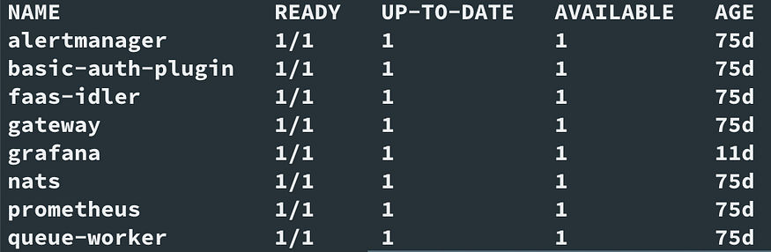

OpenFaas-Deployment

To check the status of all core containers in OpenFaas we can execute the below command.

kubectl rollout status -n openfaas deploy/gateway

The following example output shows that the gateway deployment has been successfully rolled out.

deployment "gateway" successfully rolled out

We will use the kubectl port-forward command to forward all requests made to http://localhost:8080 to the pod running the gateway service.

kubectl port-forward -n openfaas svc/gateway 8080:8080

The connection to the gateway service from our local machine will remain open for as long as the process is running. In case, if it disconnects then we can run the command again. Alternatively, we can also run it in the background using & at the end.

1.3 Install faas-cli

Once OpenFaas is installed, we must install faas-cli. The faas-cli is required to deploy and test functions with OpenFaas. Execute the following command to install faas-cli.

# MacOS and Linux users# If you run the script as a normal non-root user then the script
# will download the faas-cli binary to the current folder
$ curl -sL https://cli.openfaas.com | sudo sh# Windows users with (Git Bash)
$ curl -sL https://cli.openfaas.com | sh

OpenFass is now ready. We can login to OpenFass either using faas-cli or the UI as follows:

faas-cli login --username admin --password password123

Here, the default username is admin and the password is the one that we specified earlier during OpenFaas installation in step 1.2 Install OpenFaas.

To open the UI, navigate to http://127.0.0.1:8080 in a web browser.

2. Dockerizing Flask Application

In simple terms, dockerizing means using the docker containers to package, deploy and run applications. We will dockerize the sample Flask application which we created earlier in one of my tutorials.

2.1 Prepare the Application

Clone my sample Flask application project using the following command in any directory.

git clone https://github.com/sumanentc/python-sample-flask-application.git

You can check Sample-Flask-Application for details, how the Flask application works, the folder structure and files. We will use this Flask application to be packaged into a docker image.

2.2 Create a Dockerfile

A Dockerfile is basically a text file which has precise instructions on how to build a Docker image for our project.

Open the project folder and add a Dockerfile with the following contents:

FROM python:3.7-slim-buster
WORKDIR /home/app
COPY requirements.txt requirements.txt
RUN pip install -r requirements.txt
COPY . .
CMD python app.py

Each line in the preceding file is a command that is executed in a linear top-down approach.

FROM specifies the base container image over which the new image for our application container will be built. Here, we have taken the base image as python:3.7-slim-buster, which is an official Python image in slim variant.

WORKDIR indicates the default directory where the application will be installed. I have set it to /home/app. Any commands that are run after this would be executed from inside this folder.

COPY simply copies the files specified on the local machine to the container filesystem. I have copied requirements.txt to /home/app.

This is followed by RUN, which executes the command provided. Here, we used pip command to install all the dependencies from requirements.txt.

Then, we simply copied all the files from our current local folder, which is essentially our application root folder, to /home/app.

Finally, we used CMD to run the application by running python app.py.

We need to add the host parameter in app.py file which was downloaded while cloning the project earlier. This allows the application to be accessed outside the Docker container. The change required in app.py is highlighted as follows:

if __name__ == '__main__':
db.init_app(app)
ma.init_app(app)
app.run(port=5000, debug=True,host='0.0.0.0')

2.2 Create Docker Container Image

The creation of Dockerfile is followed by building a Docker container image using the docker build command. This will first read the Dockerfile where the instructions are written and then automatically build the image, which can then be run.

$ docker build -t sumand/python-sample-flask .

Here, we asked Docker to build an image using the Dockerfile at the same location. The -t argument sets the name/tag for the image that would be built. The final argument is a dot (.), which indicates that everything in the current folder needs to be packaged in the build.

We can check the created image using the following command:

$ docker images

Zoom image will be displayed

docker-image

2.3 Push the Image to Docker Hub

Next, we need to push the docker image to Docker Hub that will allow us to create, test, store and distribute the container images. Docker images are pushed to Docker Hub through the docker push command as follows:

$ docker push sumand/python-sample-flask:latest

Now, that the docker image is created, we can use this docker image to run the Flask application from anywhere we want.

3. Creating a Custom Function

In the previous steps, we deployed OpenFaaS to a Kubernetes cluster using the arkade CLI. Now, let us create a function using the OpenFaas template, which we can deploy in OpenFaas.

Since, we have a dockerized Flask application we will use the dockerfile template of OpenFaas to create our function as follows:

export OPENFAAS_PREFIX=sumand
faas-cli new --lang dockerfile sample-flask-service

OpenFaas functions are stored as a container image. Here, we will use DockerHub to store our image. Therefore, we are setting the environment variable OPENFAAS_PREFIX with the DockerHub username.

faas-cli new enables us to creates a new function via the dockerfile template in the current directory

Here, we have created a function called sample-flask-service using the OpenFaastemplate dockerfile.

After executing the above commands we will find that the following files were created:

sample-flask-service.yml

sample-flask-service/Dockerfile

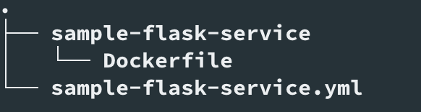

function-files

We have to update the above files according to our requirements.

3.1 Update sample-flask-service.yml

sample-flask-service.yml contains information on how to build and deploy function.

sample-flask-service.yml

The code lines are explained as follows:

Lines 1 to 4 contain information about OpenFaas and Gateway. We don’t have to change anything as we are using local OpenFass, else we need to update the gateway URL.

Line 6 contains the name of the function, which we created earlier.

Line 7 specifies the template, which we used while creating the function.

Line 8 specifies the folder (not the file) where our function code is to be found.

Line 9 specifies the Docker image name of the function, which will be built with its appropriate prefix.

Environment Variables: Lines 10 to 14 contain the environment values, which we have overridden according to our requirement.
Setting the environment variable RAW_BODY to true is required to set the context.body to the original request body rather than the default behavior of parsing it as JSON.
Also, we have updated the timeout values, as when these values are set too low they can cause the function to exit prematurely.

Autoscaling: Lines 15 to 18 are required to enable autoscaling. By default, OpenFaas will maintain at least one replica of our function so that it is warm and ready to serve traffic at any time with minimal latency. Since we need our function to be serverless we need to set com.openfaas.scale.zero:true along with faasIdler.dryRun=false, which we did earlier in step 1.2.

3.2 Update Dockerfile

Now, update the Dockerfile for our function.

DockerFile

The code lines are explained as follows:

Line 1 specifies the of-watchdog:0.8.0 as a base image. The of-watchdog implements an HTTP server listening on port 8080, and acts as a reverse proxy for running functions and microservices. It can be used to forward the request to our application.

Line 2 specifies the image of our sample flask application, which we created in step 2.

From lines 6–7 we are installing watchdog from the base image.

From lines 9–19 we are setting up non root user along with access rights.

From lines 21-27 we are setting watchdog as a startup process and upsteam_url as our flask application URL.

4. Deploying the Function

Our custom function is now ready to be deployed. Execute the following command to deploy the function.

faas-cli up -f sample-flask-service.yml

The above command internally performs the following actions:

creates a local container image of the function

pushes the image to the remote registry, which in our case is the docker hub

using the OpenFaas REST API, creates a deployment inside Kubernetes Cluster and a new Pod to serve the traffic

Now, our Flask application has been deployed as a function to OpenFaaS.

5. Testing the Function

We have deployed our function as a Serverless function with autoscaling enabled in OpenFaas. Before proceeding to test our function we must set up monitoring of the process to understand how serverless actually works. For monitoring purposes, we can use Grafana.

We can easily deploy Grafana as a pod in Kubernetes Cluster using the below command.

kubectl -n openfaas run --image=stefanprodan/faas-grafana:4.6.3 \ --port=3000 grafana

Next, use port-forward from our local computer to access Grafana without exposing it to the internet.

kubectl port-forward deployment/grafana 3000:3000 -n openfaas

Open the OpenFaas Grafana Dashboard from http://127.0.0.1:3000/. Enter the default password for Grafana, which is admin: admin. The OpenFaas Grafana Dashboard would look as follows:

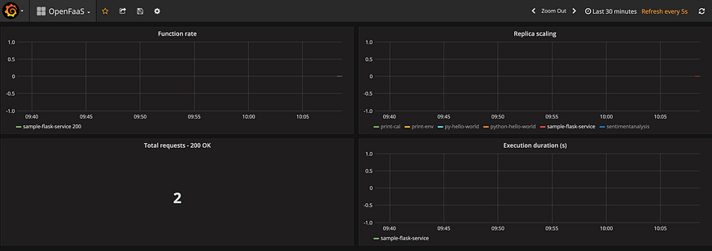

OpenFaas Grafana Dashboard

From the Dashboard, we can see that there is no running instance of our function. This is because we have enabled autoscaling along with com.openfaas.scale.zero:true in step 3. This means if we don’t have any request to process for a certain amount of time then all the functions will be stopped. This will help us to save costs.

Now, let us send a request to our flask application and check the output.

curl http://127.0.0.1:8080/function/sample-flask-service/api/items

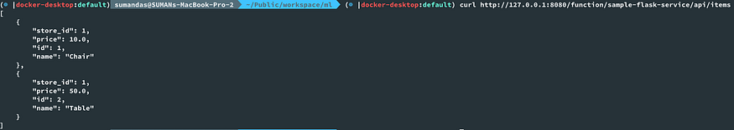

Testing one of the API exposed by our Flask application

Once our sample request is executed successfully, check the Grafana Dashboard again.

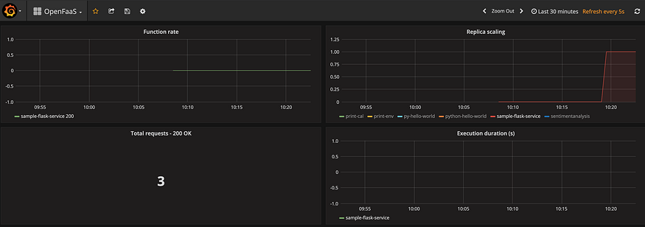

Grafana Dashboard Showing Autoscaling

From the Dashboard, we can see that the number of replicas has increased to 1 from 0 to serve the request. This replica count will further increase depending on the load till the com.openfaas.scale.max specified in step 3.1 Update sample-flask-service.yml.

The way autoscaling works in the background is that the requests are blocked until the desired count of replicas are achieved. We can verify that from the gateway logs as follows:

kubectl logs -n openfaas deploy/gateway -c gateway -f

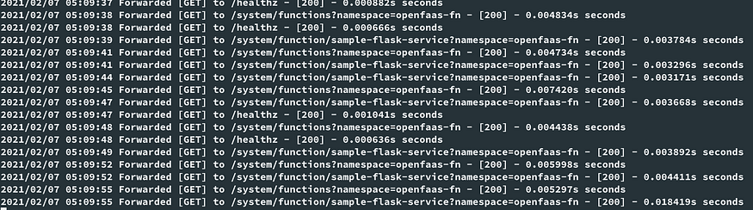

Gateway Logs for replica count

Since we have enabled com.openfaas.scale.zero:true in our function, it will scale down automatically when not in use. We can verify the same in the Dashboard.

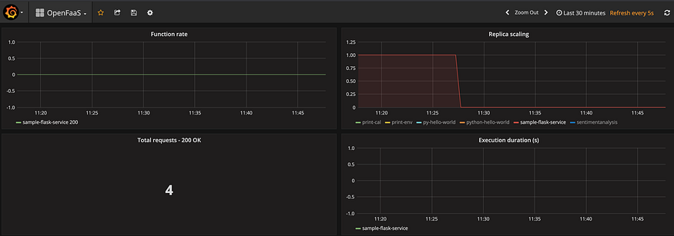

Now, all the APIs of our Sample Flask application are available in OpenFaas and can be executed in a serverless manner.

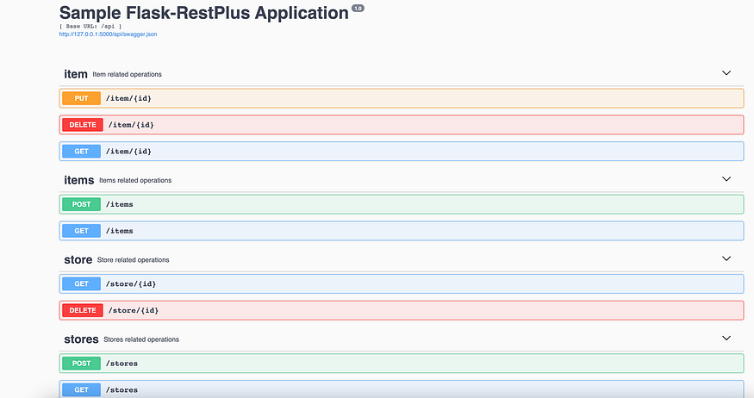

Result :

Viva questions:
- What is OpenFaaS and how does it work?
- What is the difference between traditional servers and serverless architecture?
- How do you trigger an OpenFaaS function?
- How does OpenFaaS support different event sources?
- What is the role of faas-cli?

Exno 13: CloudSim in Eclipse

Aim:
To Simulate a cloud scenario using CloudSim and run a scheduling algorithm that is not present in CloudSim.

Procedure:

CloudSim is written in Java. The knowledge you need to use CloudSim is basic Java programming and some basics about cloud computing. Knowledge of programming IDEs such as Eclipse or NetBeans is also helpful. It is a library and, hence, CloudSim does not have to be installed. Normally, you can unpack the downloaded package in any directory, add it to the Java classpath and it is ready to be used. Please verify whether Java is available on your system.

To use CloudSim in Eclipse:

- Download CloudSim installablefilesfrom https://code.google.com/p/cloudsim/downloads/list and unzip
- OpenEclipse
- Create a new Java Project: File ->New
- Import an unpacked CloudSim project into the new JavaProject
- The first step is to initialise the CloudSim package by initialising the CloudSim library,as follows:

CloudSim.init(num_user, calendar, trace_flag)

- Data centres are the resource providers in CloudSim; hence, creation of data centres is a second step. To create Datacenter, you need the DatacenterCharacteristics object that stores the properties of a data centre such as architecture, OS, list of machines, allocation policy that covers the time or spaceshared, the time zone and itsprice:

Datacenter datacenter9883 = new Datacenter(name, characteristics, new VmAllocationPolicySimple(hostList),s

- The third step is to create abroker:
DatacenterBroker broker = createBroker();

- The fourth step is to create one virtual machine unique ID of the VM, userId ID of theVM’s owner, mips, number Of Pes amount of CPUs, amount of RAM, amount of bandwidth, amount of storage, virtual machine monitor, and cloudletScheduler policy forcloudlets:

Vm vm = new Vm(vmid, brokerId, mips, pesNumber, ram, bw, size, vmm, new CloudletSchedulerTimeShared())

- Submit the VM list to thebroker: broker.submitVmList(vmlist)

- Create a cloudlet with length, file size, output size, and utilisationmodel:
Cloudlet cloudlet = new Cloudlet(id, length, pesNumber, fileSize, outputSize, utilizationModel, utilizationMode

- Submit the cloudlet list to thebroker: broker.submitCloudletList(cloudletList)

- Start
thesimulation: CloudSim.startSimulation()
Sample Output from the Existing Example: Starting

CloudSimExample1... Initialising...
Starting CloudSim version 3.0 Datacenter_0 is starting...

>>>>>>>>>>>>>>>>>>>>>>>>>>>>>>>>null
Broker is starting... Entities started.
: Broker: Cloud Resource List received with 1resource(s) 0.0: Broker: Trying to Create VM #0 inDatacenter_0
: Broker: VM #0 has been created in Datacenter #2, Host#0 0.1: Broker: Sending cloudlet 0 to VM #0
400.1: Broker: Cloudlet 0 received
: Broker: All Cloudlets executed.Finishing. 400.1: Broker:
Destroying VM#0
Broker is shutting down... Simulation: No more future events
CloudInformationService: Notify all CloudSim entities for shutting down. Datacenter_0 is shutting down...
Broker is shutting down...
Simulationcomplet ed.
Simulation completed.

OUTPUT :
Cloudlet ID STATUS Data center ID VM ID Time Start Time FinishTime
0 SUCCESS 20 400 0.1 400.1
*****Datacenter:Datacenter_0***** Userid Debt
3 35.6

CloudSimExample1 finished!

RESULT:

Thus the scheduling algorithm is created with the CloudSim.

Viva questions:
- What is CloudSim?
- What are the main components of CloudSim?
- Why did you choose this scheduling algorithm?
- What are the drawbacks of Shortest Cloudlet First?
- What happens if more cloudlets than VMs are submitted?

